**WATCH this**

**Karpathy how he** [**uses LLMS**](https://www.youtube.com/watch?v=EWvNQjAaOHw)**.**

**Lovable for** [**Product managers**](https://www.youtube.com/watch?v=DZtGxNs9AVg)

**For competitors research - perplexity.ai**

Working book [Link!!!](https://docs.google.com/spreadsheets/d/1eQwum40OD8rl8u-t5X_0trYgtWE68p-i51aCzaFUPUA/edit?gid=1606337275#gid=1606337275)

Lecture 1

1. “Have you ever thought about starting your own business in Kazakhstan?” (Yes / No / Maybe)
2. “Which industry interests you the most?” (Options: IT Services, E-commerce, Food & Beverage, Logistics, Marketing Agency, Other)

*Decline in bus activity stats from* [*Kursiv.kz*](https://kz.kursiv.media/en/2025-01-09/engk-tank-kazakhstan-reports-decline-in-business-activity/?utm_source=kursiv&utm_campaign=read_more)

“Kazakhstan has a growing market for small and medium enterprises (SMBs). With government support programs, expanding digital infrastructure, and a young, tech-savvy population, this is a good time to understand the basics of business management.

Majority of businesses is not profitable. Many people have 2-3 empty legal entities.

Boring business is good

<https://www.bizscout.com/signup>

Some businesses are more ‘boring’—like distribution, logistics, or cleaning services—but they can be surprisingly profitable if managed well. We’ll explore how these ‘boring’ industries can actually create stable revenue.”

**Core Pillars of Business Management (Kotler)**

* **Product**
* **Place**
* **Promotion**
* **Price**

**Brand management (Integrated marketing communication - Schultz). Strategic marketing manager.**

**One message in all channels constantly:**

* **Channel 1 (Insta)**
* **Channel 2 (PR article in forbes)**
* **Channel 3 Influencer media**
* **Channel N…**

**ROMI (return on marketing investment)**

**Books:**

1. **Marketing warface, Al Ries and Jack Trout**
2. **Schultz - Integrated marketing communications**

Task 1. Split to group maximum 4 people in group. Or you can work alone. Or less then 4 people.

1. Find business industry you are interested in
2. Find 3 companies in KZ who already do this business
3. Rate all 3 companies according to this 4P

*Product   1…5*

*Place   1…5*

*Promotion (Branding power)   1…5*

*Price   1…5*

*Naming power (less words or sticky word)   1…5*

**Direct / indirect competitors**

Eric Ross' map of world trade networks in 1340 (1/2), with major regional zones of trade indicated…

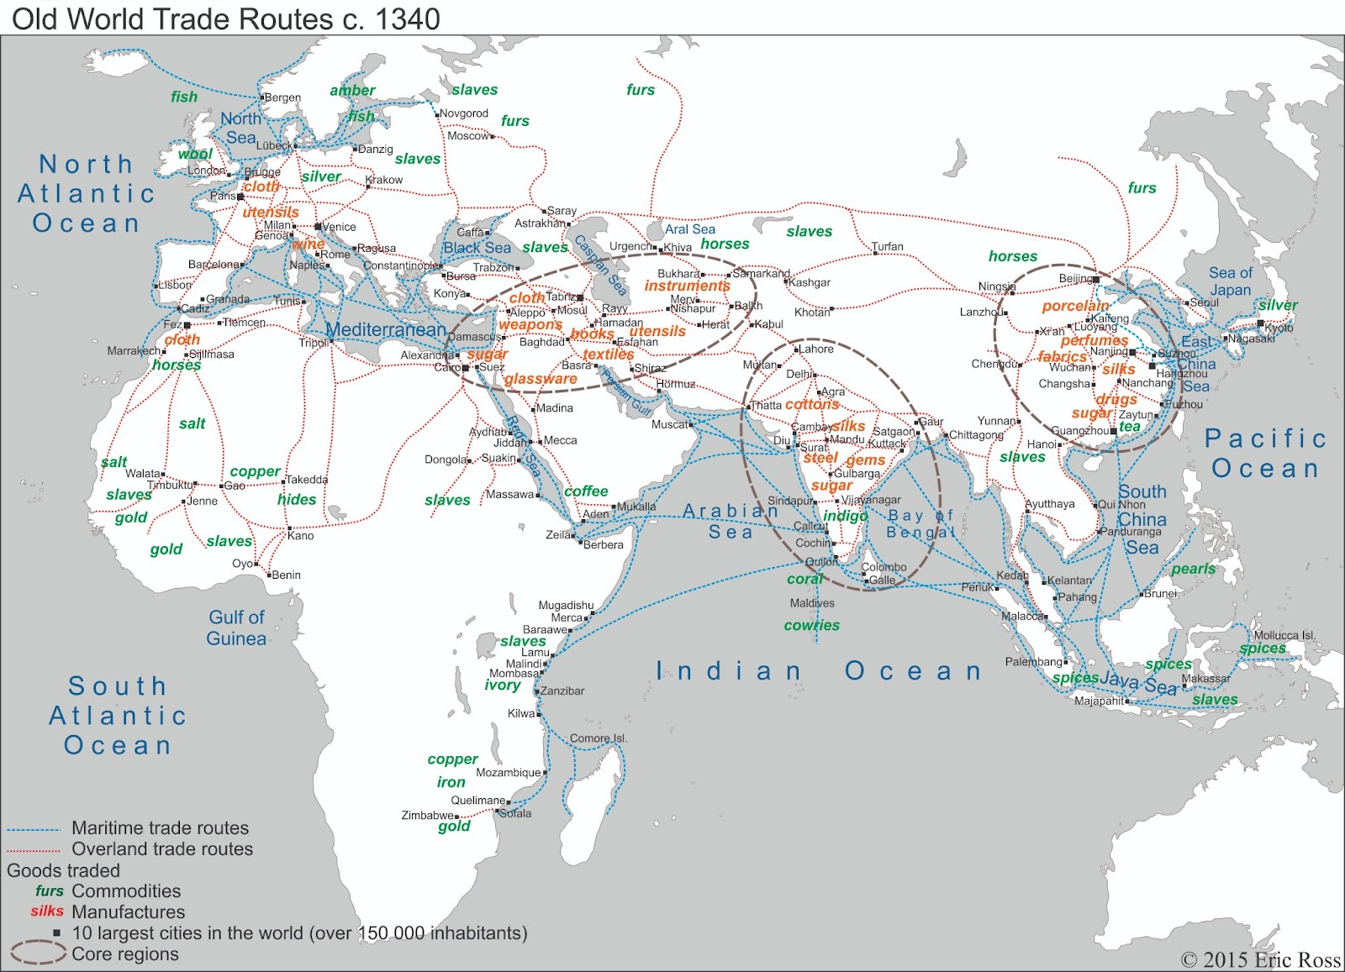

Over the semester, we’ll learn about strategic planning, marketing, finance, and operations. Each module connects back to **building or running a profitable SMB**, especially in Kazakhstan. We’ll also talk about tech tools—like online platforms—to help automate parts of your operation.”

* **Suggested List of Websites** to keep an eye on for operations management, marketing, and business:
  + **For Operations & Logistics**:
    1. [SourceForge Logistics Software](https://sourceforge.net/software/logistics/) (Comparisons of logistics & supply chain tools)
    2. [BizScout](https://www.bizscout.com/signup) (Business scouting, SME growth)
  + **For Marketing & Advertising**:
    1. [HubSpot Blog](https://blog.hubspot.com/) (Inbound marketing insights)
    2. [Neil Patel](https://neilpatel.com/) (SEO & digital marketing tips)
  + **For General Business & Trends**:
    1. [Harvard Business Review](https://hbr.org/) (Global insights, strategy)
    2. [Entrepreneur.com](https://www.entrepreneur.com/) (SMB success stories, how-to articles)
  + **Local Kazakhstani Resources**:
    1. [Atameken](https://atameken.kz/) (National Chamber of Entrepreneurs of Kazakhstan)

* + Taking a **practical approach** to business opportunities.
  + **Tracking** relevant websites and resources regularly.
  + Engaging in **quick market research** and brainstorming.

“For next time, think about one real or hypothetical business idea that you might want to explore throughout this course. Write a short paragraph describing it and why it interests you. We’ll use these ideas in our upcoming assignments.”

“Remember, big companies often start small—just like the many local entrepreneurs we’ll hear about this semester. If you have an idea, keep refining it. If you’re not sure what to do yet, keep learning, observing, and asking questions. I hope today’s session inspired you to see that opportunities do exist—especially here in Kazakhstan, where the market can still grow in many directions.”

**Lecture 2: Operations management, org structure & leadership**

Operations management - fighting stagnation.

Operations management - lead to order (structured expectations)

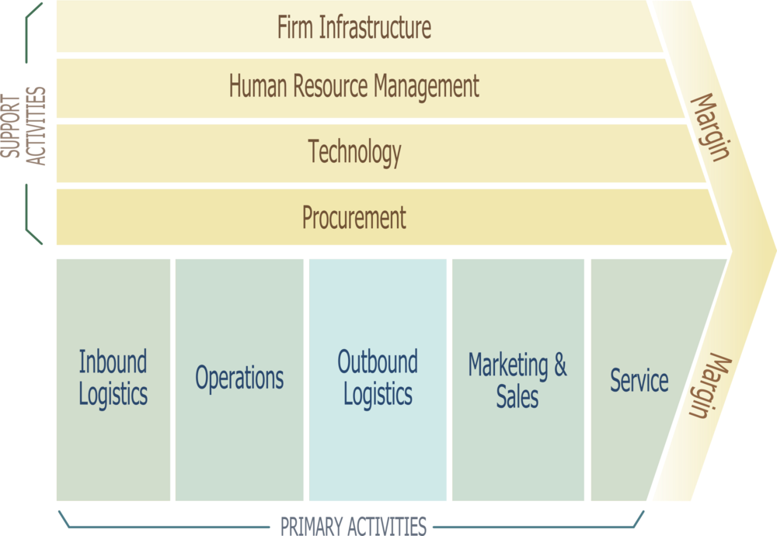

**Value chain Michael Porter**

**Template here** [**CLICK HERE!**](https://docs.google.com/spreadsheets/d/1WkyenMcXCkzq4Djyjgjfz_SWbv2_cE1tDkoqvLztsNk/edit?usp=sharing) **Porter**

**Template BUS Canvas** [**Click here!**](https://docs.google.com/spreadsheets/d/1qgrW-qMcER7dfciWdAZIHDpLPXdAsLGsD6SonKg7oqg/edit?gid=0#gid=0)

1. **Organizational Structure**
   * Functional vs. divisional vs. matrix structures.



**Org structure Key types**

**•   Functional Structure: Grouped by expertise (e.g., marketing, finance).**

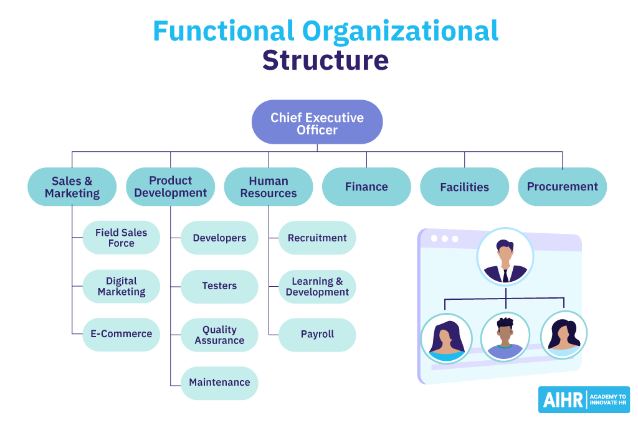

         •   Divisional Structure: Grouped by products, services, or geography.

         • **Matrix Structure: Combines functional and divisional.**

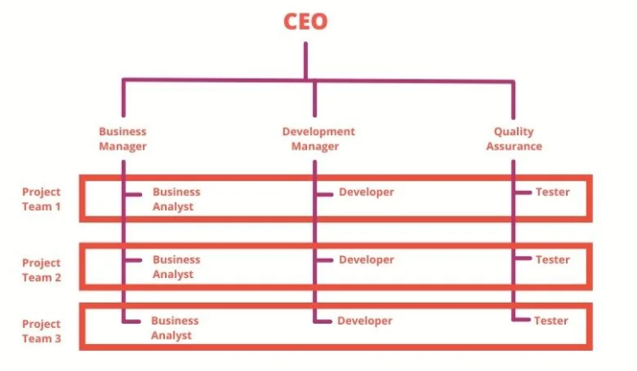

      •   Advantages and challenges of each structure.

Examples for Kazakhstan:

   •   Functional structure in a large Kazakh mining corporation.

   •   Divisional structure in an international retail company operating in Kazakhstan.

   •   Matrix structure in a local IT company collaborating with global partners.

1. **Leadership Styles**
   * Autocratic, democratic, laissez-faire, transformational.
   * Adapting style to context (tech-driven vs. traditional industries).

**Types of Leadership Styles**

      •   Autocratic: Centralized authority; fast decisions.

      •   Democratic: Inclusive; fosters collaboration.

      •   Laissez-Faire: Hands-off; ideal for skilled teams.

      •   Transformational: Inspires and drives change.

      •   Situational Leadership: Adapting style based on team and context.

**Centralization vs. decentralization.**

      •   Centralized organizations: Decisions made by top management.

      •   Decentralized organizations: Authority distributed across levels.

      •   Benefits and drawbacks of both approaches.

Ukraine

      •   A centralized government ministry vs. a decentralized tech startup.

BREAK 15 minutes

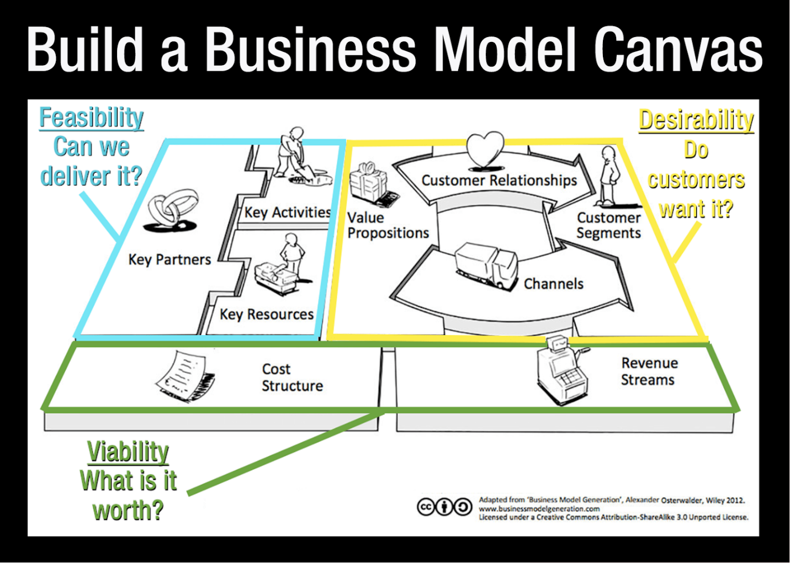

**Value canvas**

**Template here** [**CLICK HERE!**](https://docs.google.com/spreadsheets/d/1WkyenMcXCkzq4Djyjgjfz_SWbv2_cE1tDkoqvLztsNk/edit?usp=sharing) **Porter**

**Template BUS Canvas** [**Click here!**](https://docs.google.com/spreadsheets/d/1qgrW-qMcER7dfciWdAZIHDpLPXdAsLGsD6SonKg7oqg/edit?gid=0#gid=0)

1. **Tech-Driven Organizational Models**

**2GIS - Digital first. Digital innovations organizing logic**

* Flat structures in software startups.
* Remote/hybrid teams and global collaboration.

**SIS 1 Write a strategy for your project.**

Flat Structures in Tech Startups

   •   Content:

      •   Flat structures: Few management layers; fast decision-making.

      •   How tech startups leverage this for innovation.

Examples:

   •   A Kazakh tech startup vs. a global corporation like Google.

1.3 Case Study: Comparing Structures

   •   Students read a short case about a KASPI acquiring [HEPSIBURADA](https://tech.eu/2024/10/18/kaspikz-acquires-majority-share-of-hepsiburada-for-11b/)

   •   Task: In breakout groups (online), they:

      •   Identify the most suitable structure for the company.

      •   Justify their choice with examples.

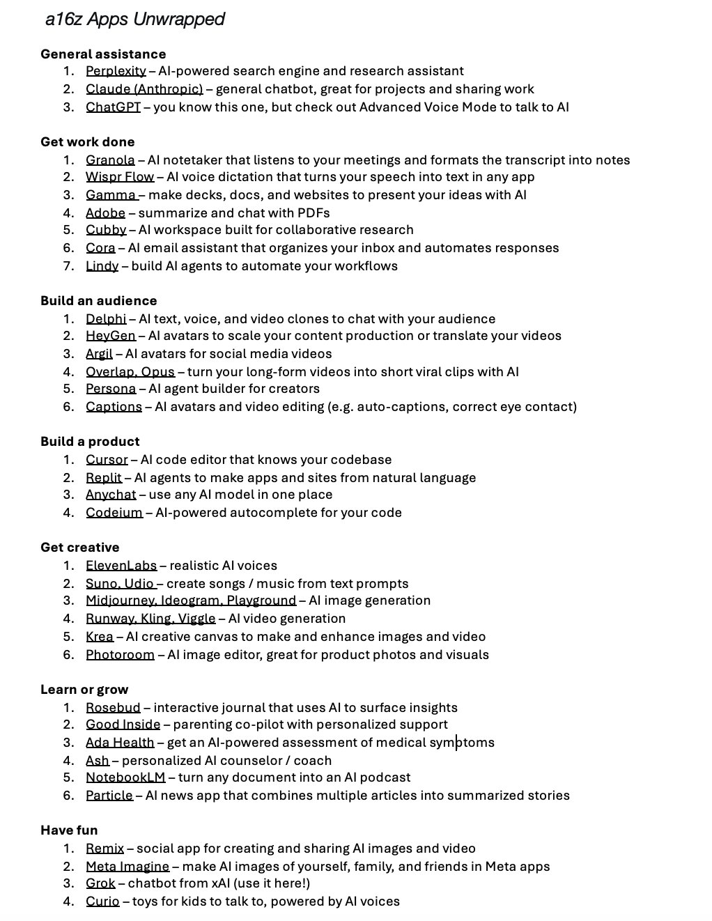

**Lecture 3: Strategy & Competitive Advantage**

Key Themes & Concepts

1. **Strategic Management Basics**
   * Vision, mission, goals.
   * Corporate-level vs. business-level strategies.
2. **Porter’s 5 Forces & SWOT Analysis**
   * Industry analysis for competitive positioning.
   * Strengths, Weaknesses, Opportunities, Threats.
3. **Aligning Strategy with Technology**
   * How IS can be a source of sustainable competitive advantage.
   * Real-world examples (Amazon, Alibaba, etc.).
4. **Discussion / Activity**
   * **Case Analysis:** Harvard/Stanford business case on a tech startup or multinational. Students practice SWOT & 5 Forces.

Readings & References

* **Harvard Business Review** (Case Studies) – [HBS Case Collection](https://hbsp.harvard.edu/cases/)
* Select article on strategy from [Stanford GSB Case Library](https://www.gsb.stanford.edu/faculty-research/case-studies)

**Innovators Dilemma**

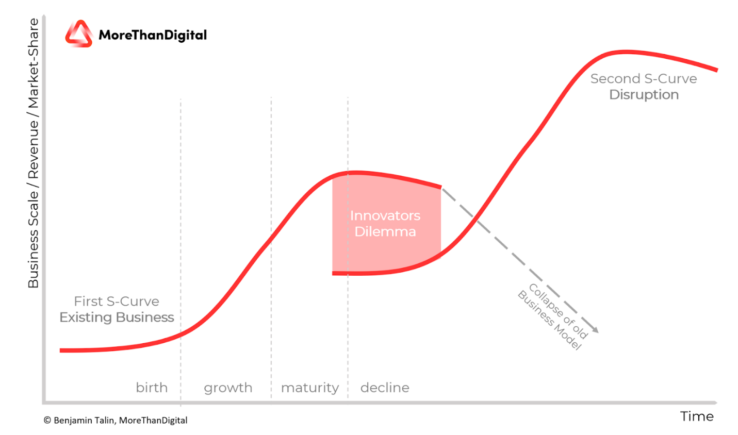

**SWOT**

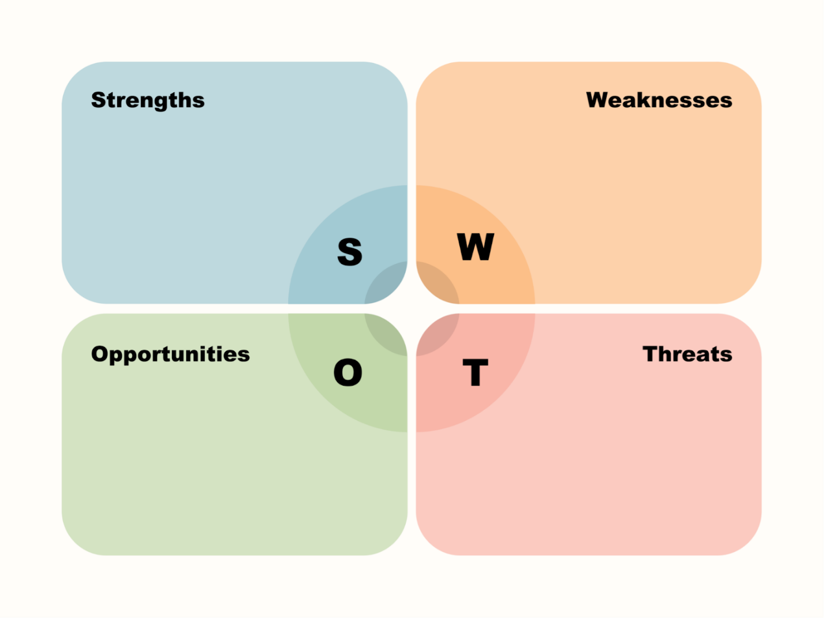

**AAAR**

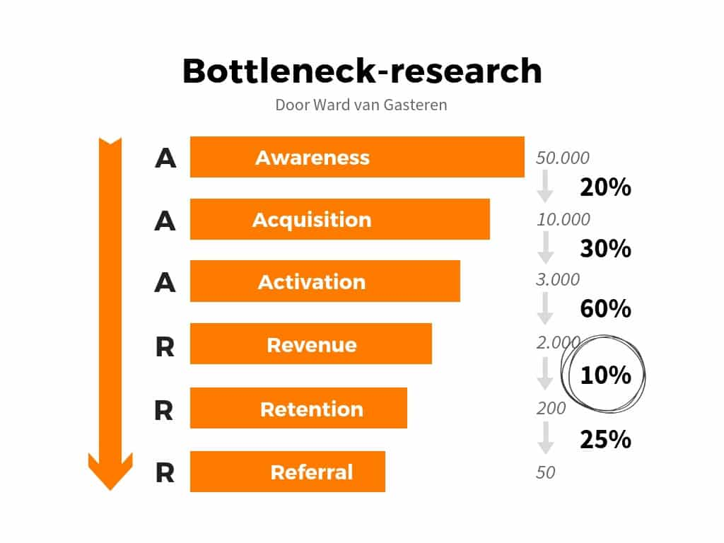

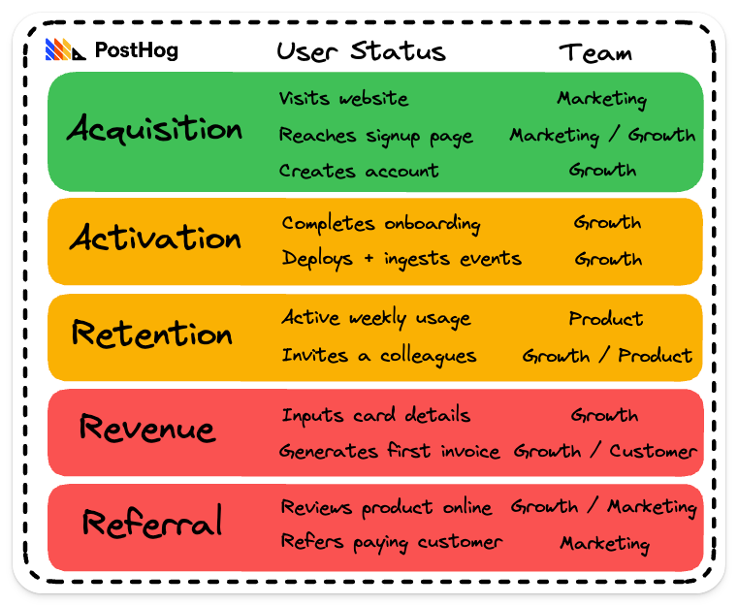

**What is a Life time Value? LTV**

**What is MRR? Monthly recurring revenue!**

**AIDA**

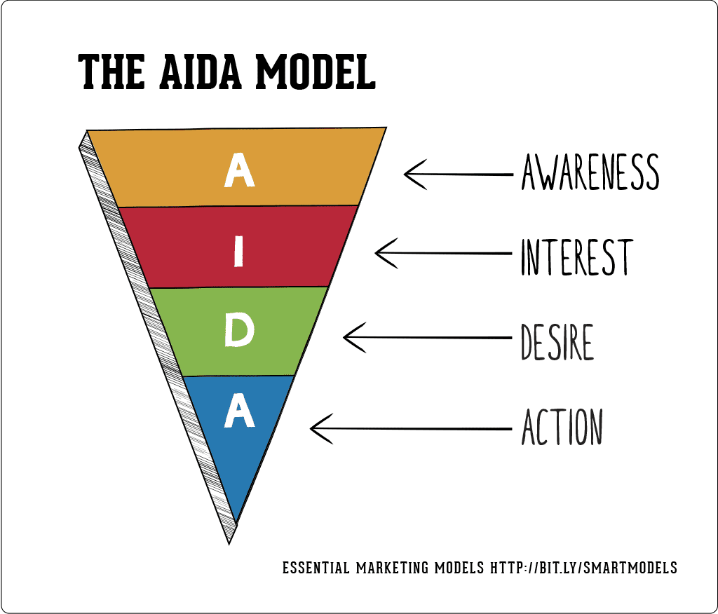

**SIS 2. Market plan**

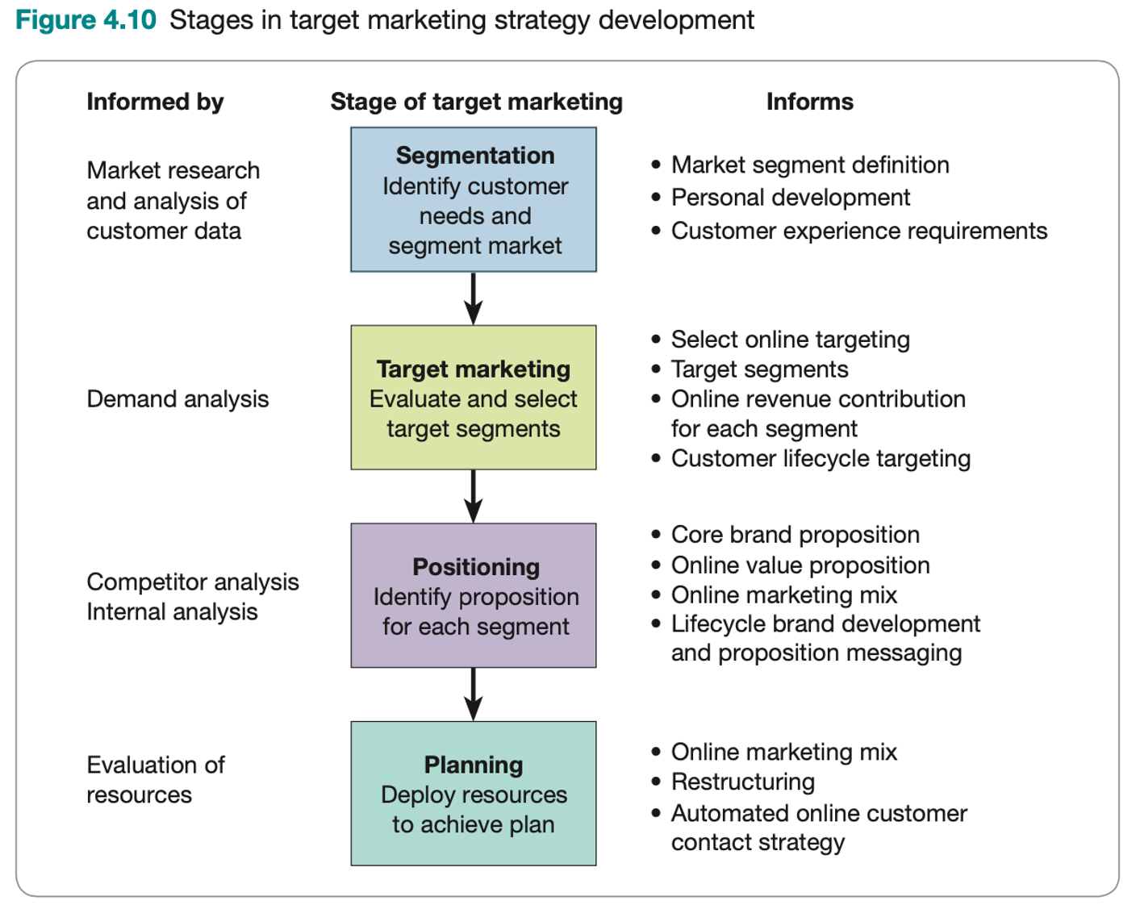

Market plan template

<https://docs.google.com/spreadsheets/d/13iSeQgBORYJUNxmhlUheVf6tUbsA40oZEDIR1s4OJ3A/htmlview>

**SIS 2. Audit of marketing strategy and communications. 20 points. Deadline week 10 to submit link.**

**Use automated tools such as brand analytics, semrush, perplexity, semantic force etc.**

1. **Create Google sheets**
2. **Brand’s opportunities in KZ What industry pick one and analyze:**
3. **Segment of customer (personas)**
4. **Channels (i.e. youtube ads, offline banners, insta influencers promote it?)**
5. **Try to calculate CPA (cost per customer acquisition) for the channels you identified**
6. **Message (positioning)**
7. **Message Tonality (BERT via colab notebook) sentiment analysis**
8. **Try to identify average check (price of the company product/service)**
9. **Try to calculate rough margin**
10. **Submit google sheets link to the working file with student IDs. Maximum 4 people in group. Or less or even solo.**

**Week 4. Operations Management Essentials (I)**

Last week recap:

Innovators dilemma - after 10 years. Resource renewal Teece. Ammortization who remember? As a manager. Start buying for your parents a house in Turkey.

Useless if you don’t speak to the customer. Not just user story. Otherwise solution for solution. People laugh.

Youngjin - LMA means you can turn your business model as a constructor.

B2B model

B2C Model. That is why its better to be the first. All want to be the first. Move to other - almost never if B2B. If consumer maybe.

Being first. All want to be first. Digital Almaty. Crappy?

Example how first and speaking to the customer.o

11 labs vs Open AI. 11 labs deployed model and via social media startted early. Now they know what features, geographies, policies work. It cost a lot. 76% of OpenAI revenue comes from Consumers. Other from B2B. 11 labs goes for B2B and beats them.

Perplexity - build your brand. So investors of other startups are afraid

Mistral, LLama adoption is low in compared to SaaS? Why? Because organizational routine. For people it’s a challenge.

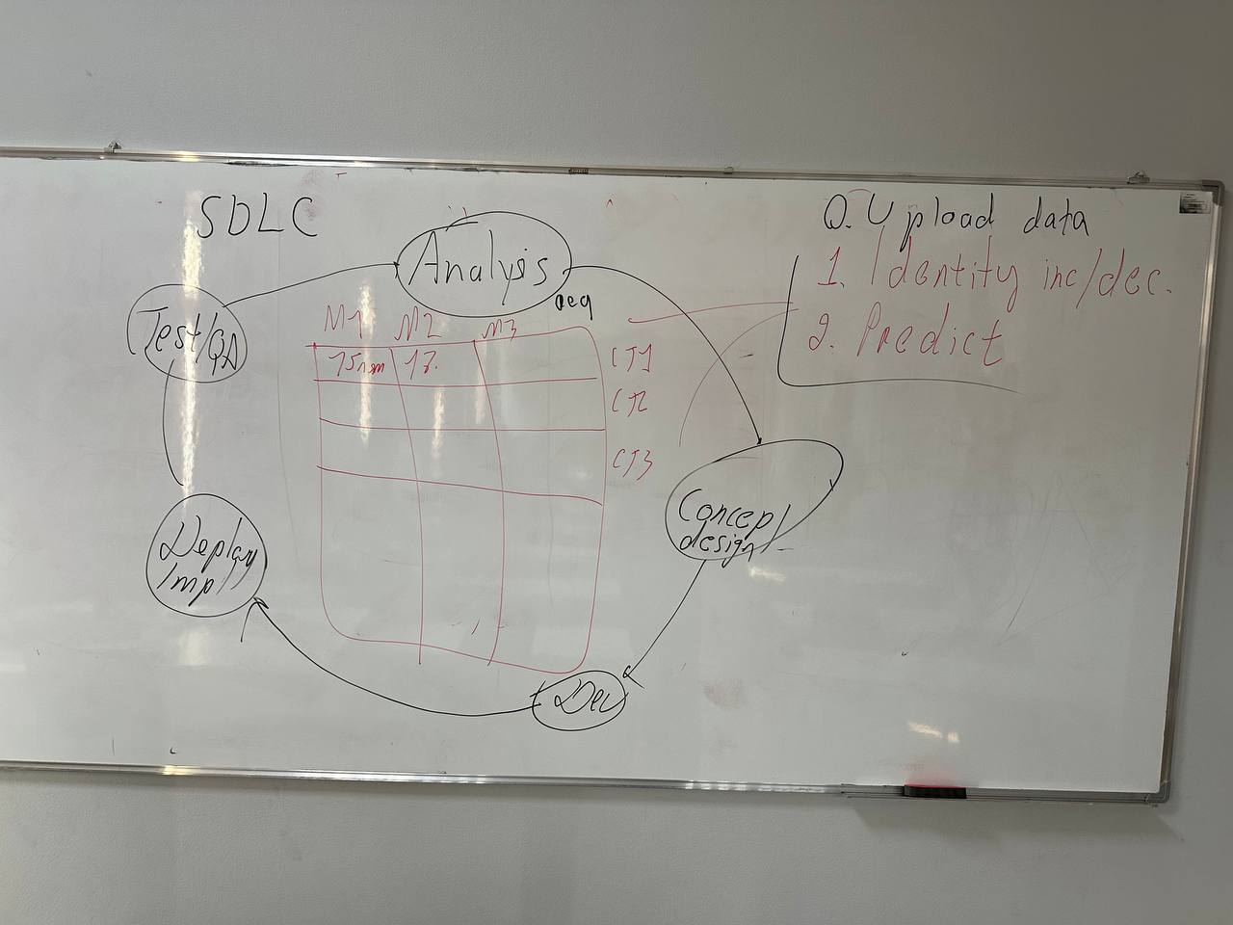

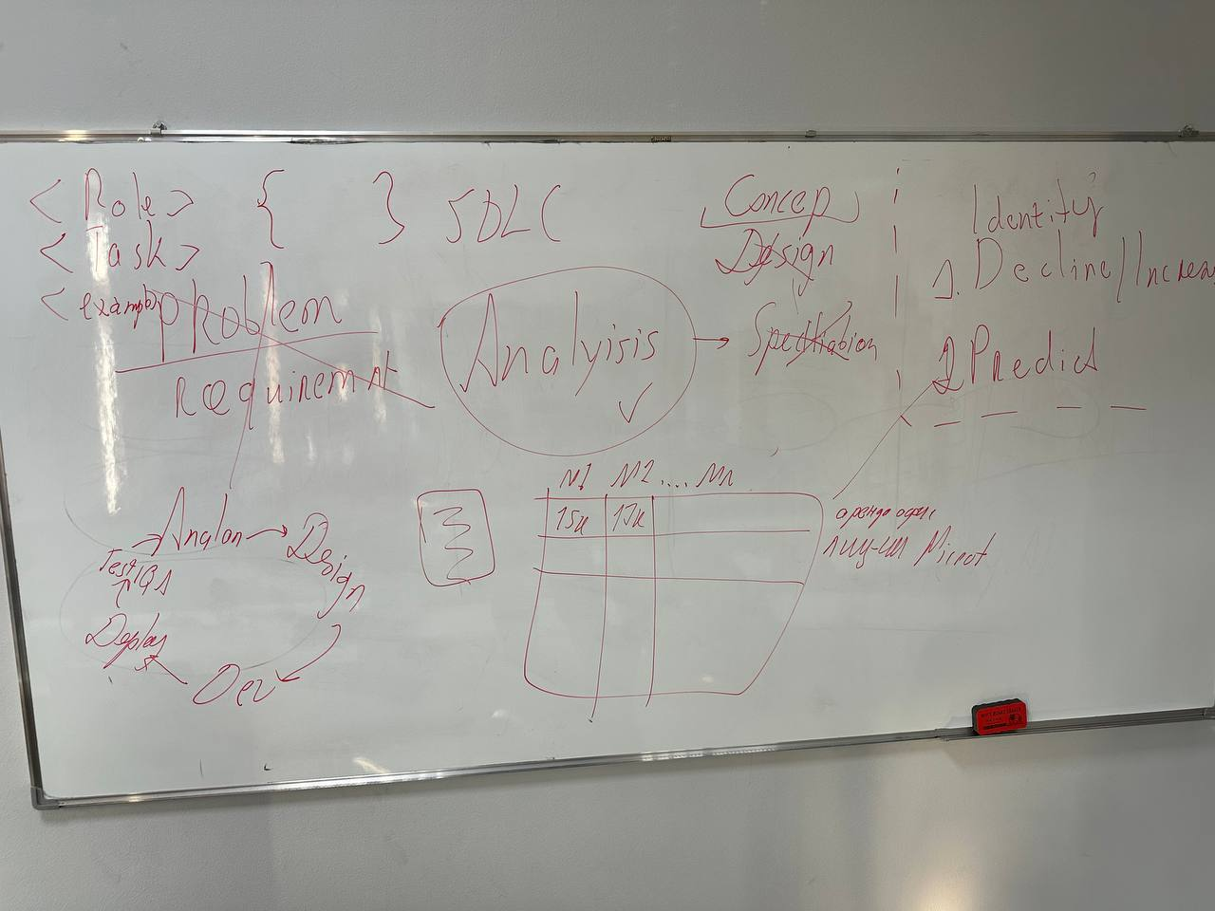

For what feels like a long time in AI, 2-year old ElevenLabs had a pretty clear run in the voice cloning and text-to-speech market. It was up against half-hearted, underpowered offerings from big tech companies or slow, unintuitive open source models like Tortoise.

Although larger players like OpenAI built powerful text-to-speech models, they [adopted slow and cautious](https://substack.com/redirect/90fde414-f8c3-4207-bbb8-188088bf0270?j=eyJ1IjoiZnF3MCJ9.yHmxuztJPHLeAWnkoPZ2K5FiuXm1TSheQXlusmX-MK8) release strategies.

It’s not difficult to understand why. With frontier labs already embroiled in a series of legal disputes around copyright, they probably didn’t want to be accused of flooding the Internet with deep fakes in the run-up to a series of globally significant elections. But this is already beginning to change.

So should start-ups like ElevenLabs be worried?

In [a recent interview](https://substack.com/redirect/4487f59e-0a52-4408-8814-50468bc0c604?j=eyJ1IjoiZnF3MCJ9.yHmxuztJPHLeAWnkoPZ2K5FiuXm1TSheQXlusmX-MK8), Carles Reina, VP Revenue at ElevenLabs, shared an interesting perspective:

*We're seeing mid-market logistics companies, hospitals, and 200-employee e-commerce companies all wanting to implement AI. They see the benefits but don't have the resources to do it themselves. This changes how I, at Eleven Labs, approach customers but also gives long-term moats, contracts, and success. Once you secure one of these non-tech customers, they're likely to stay with you - they don't want to change, unlike big tech companies that can easily switch APIs.*

This touched on something important and often under-appreciated by those building in AI: disruption is *actually* *pretty hard*. Being better than the rest can compensate for not being first, but it’s not guaranteed.

This week we’re going to talk about the importance of speed, the challenge of friction and inertia, and what we can learn from this.

Being first

When we get asked what we look for in founders, we obviously mention engineering and product brilliance, but equally important is a strong dose of technical pragmatism and customer obsession. We’ve met many gifted builders who sometimes forget that category-defining businesses aren’t built solely by publishing papers reporting impressive benchmark performance in a lab setting. Indeed, as we’ve written elsewhere, [good technology does not speak for itself](https://substack.com/redirect/0c438918-b5e5-4c65-a6c6-c9503b147ad9?j=eyJ1IjoiZnF3MCJ9.yHmxuztJPHLeAWnkoPZ2K5FiuXm1TSheQXlusmX-MK8).

While it’s possible to make your fortune off the back of a consumer app that goes viral, this is rare to capture lightning in a bottle.

Instead, the companies that succeed often have to i) convince someone to buy what they are selling; ii) regear their existing systems to integrate it; iii) potentially retrain their team; and iv) experience some short-term disruption or reduction in productivity to unlock long-term advantage.

This is possible, but it’s hard and it’s why most start-ups don’t succeed.

But it also means that if you’re first, you have a strong moat.

ElevenLabs was prepared to [endure early controversy](https://substack.com/redirect/3869ea11-c0ec-4e82-bb11-558ce391d236?j=eyJ1IjoiZnF3MCJ9.yHmxuztJPHLeAWnkoPZ2K5FiuXm1TSheQXlusmX-MK8) around the misuse of its product that scared off big tech labs.

Thanks to a good product, an early lead, and mindshare built through Instagram and TikTok creators, it built strong loyalty as it moved upmarket, with users [at over 60%](https://substack.com/redirect/af39e2fe-066c-4502-8036-46a106515b6f?j=eyJ1IjoiZnF3MCJ9.yHmxuztJPHLeAWnkoPZ2K5FiuXm1TSheQXlusmX-MK8) of Fortune 500 companies. It will have significantly more data than potential competitors on what users like and don’t like, which features drive growth versus which aren’t worth the investment, promising sectors and geographies, regulatory experience, and investors aligned with the vision.

Someone who’s built a good text-to-speech model in a lab, even if it’s theoretically better, will have none of these advantages. While they might be able to convince a few AI-native users who enjoy hacking things together to trial their work, convincing enterprise users with better things to do that they should switch from a product they already like is much harder.

You could make a similar argument about Synthesia, the AI-first video avatar platform, which outpaced HeyGen and Hour One, to build significant Fortune 500 uptake. This is a daunting lead for a new entrant to overcome:

|  |  |  |
| --- | --- | --- |
|  |  |  |

There’s also a point about mindshare. Perplexity’s AI-powered search product likely isn’t yet deeply intertwined with many org’s tech stacks, but the company has invested significantly in brand, simply to drown out the voice of any potential competitor - going to lengths that few others would.

**Week 5. Finance and Investments basics**

Financial Accounting - бух учет

Managerial accounting - управленческий учет

CAP table - структура управления и учредителей

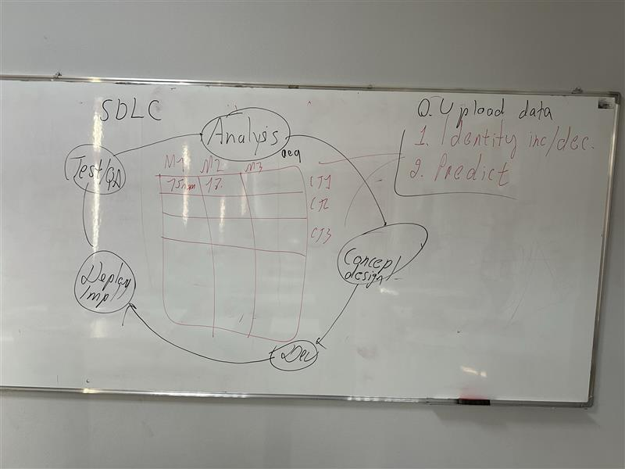

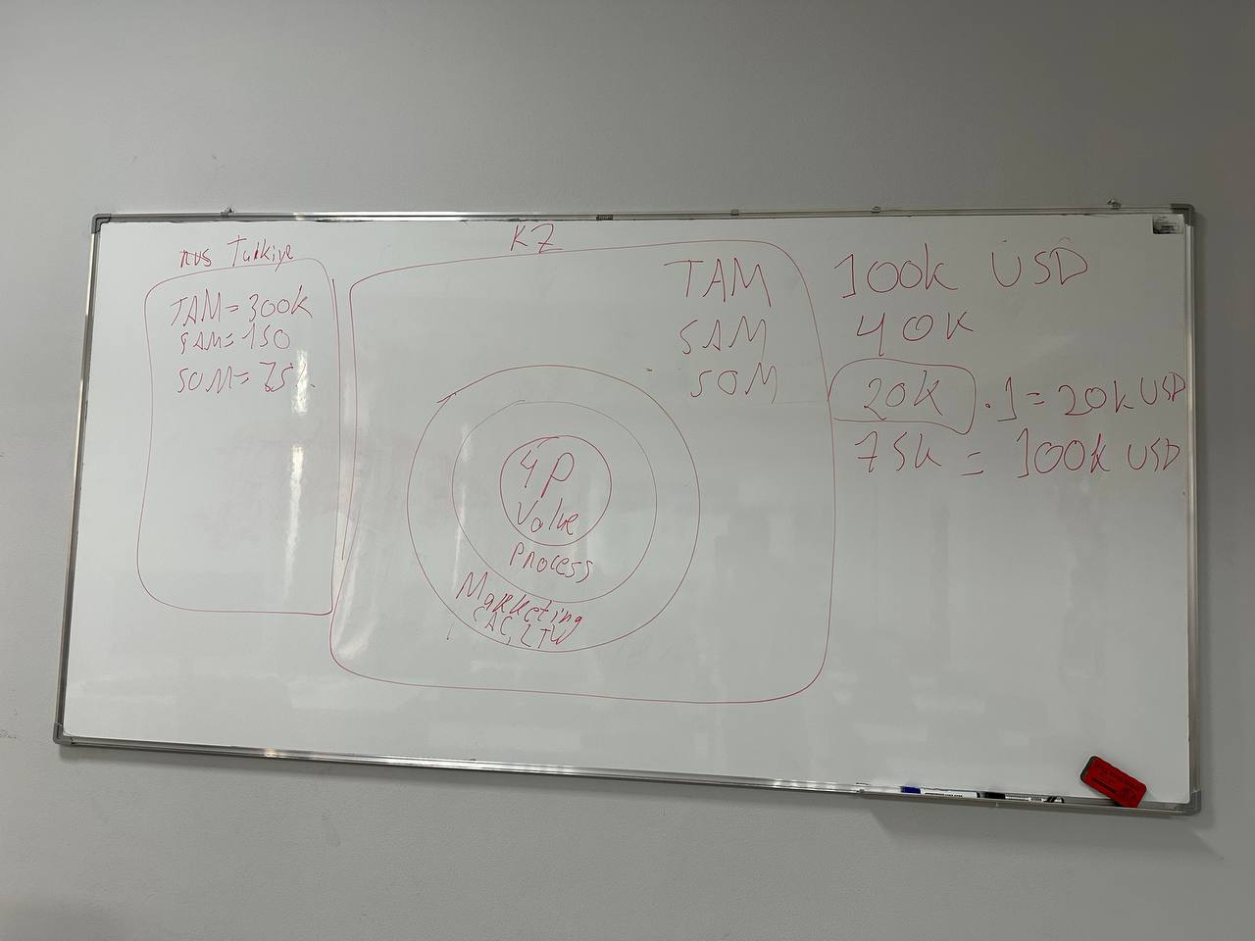

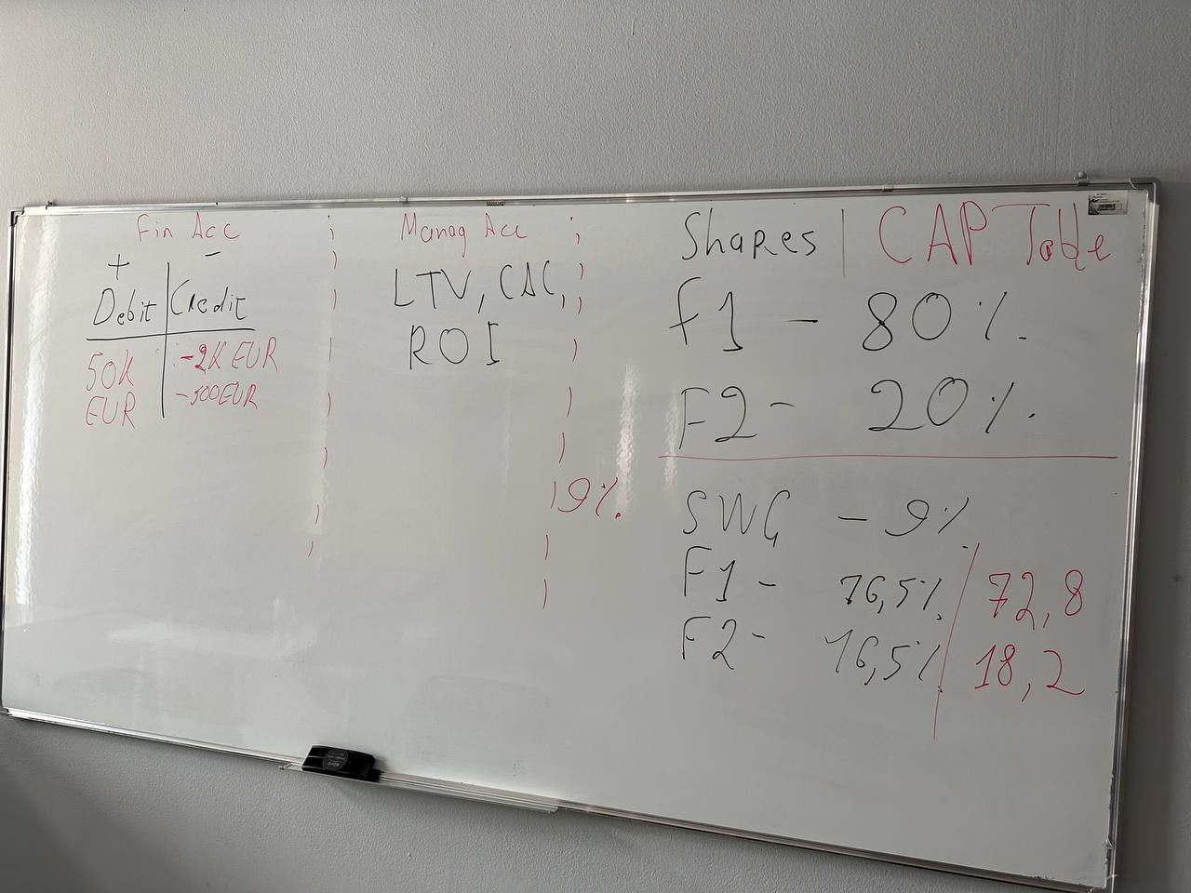

**Week 6: Product Strategy & Business Models**

1. Jobs to Be Done (JTBD)
   * Core frameworks: Clayton Christensen, Bob Moesta, Tony Ulwick’s ODI.
   * Uncovering why customers “hire” products.
2. Business Model Canvas & Revenue Models
   * Key partners, activities, resources, cost structure, and revenue streams.
   * Examples: subscription (SaaS), pay-per-use, licensing, freemium.
3. Aligning Product Features with Customer “Jobs”
   * Distinguishing features vs. benefits.
   * Prioritizing features that solve the most pressing “jobs.”
4. Discussion / Activity
   * Case Discussion: Use a real or hypothetical product to map its business model.
   * Assignment #2: Draft a “Product Canvas” that outlines your emerging product’s strategy and how it monetizes.

Readings:

* Read this UX case study by Apple  <https://www.apple.com/newsroom/2020/01/apple-delivers-a-new-redesigned-maps-for-all-users-in-the-united-states/>
* Read this **The Next Frontiers of Digital Innovation Research** <https://pubsonline.informs.org/doi/full/10.1287/isre.2024.editorial.v35.n4>

**Jobs to be done**

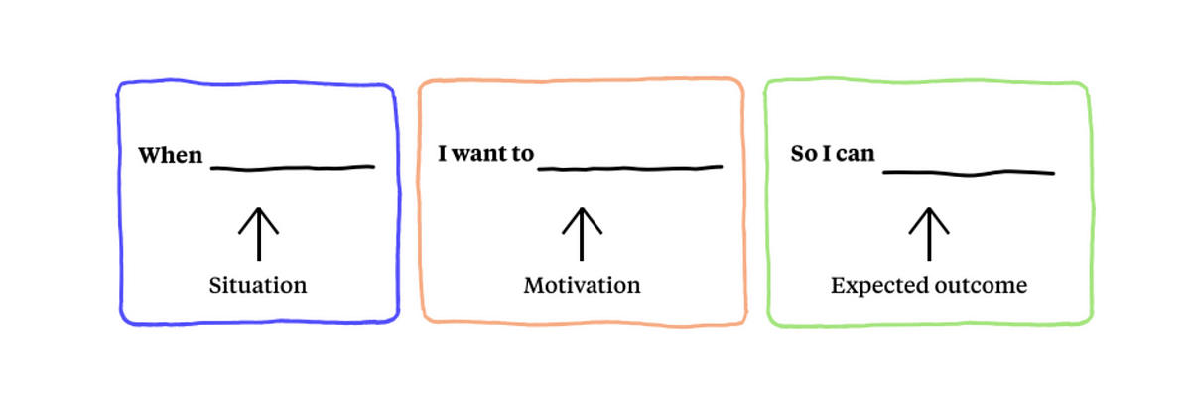

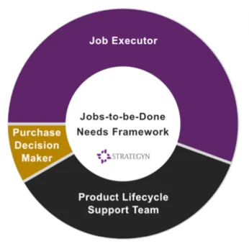

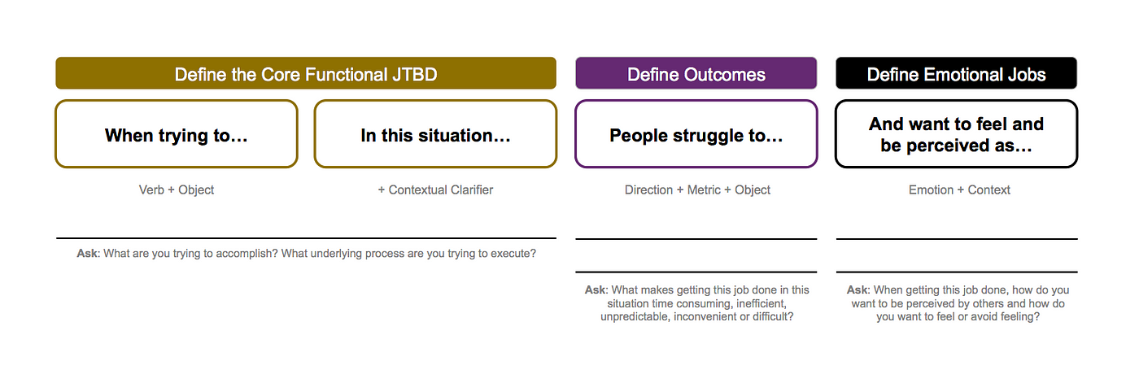

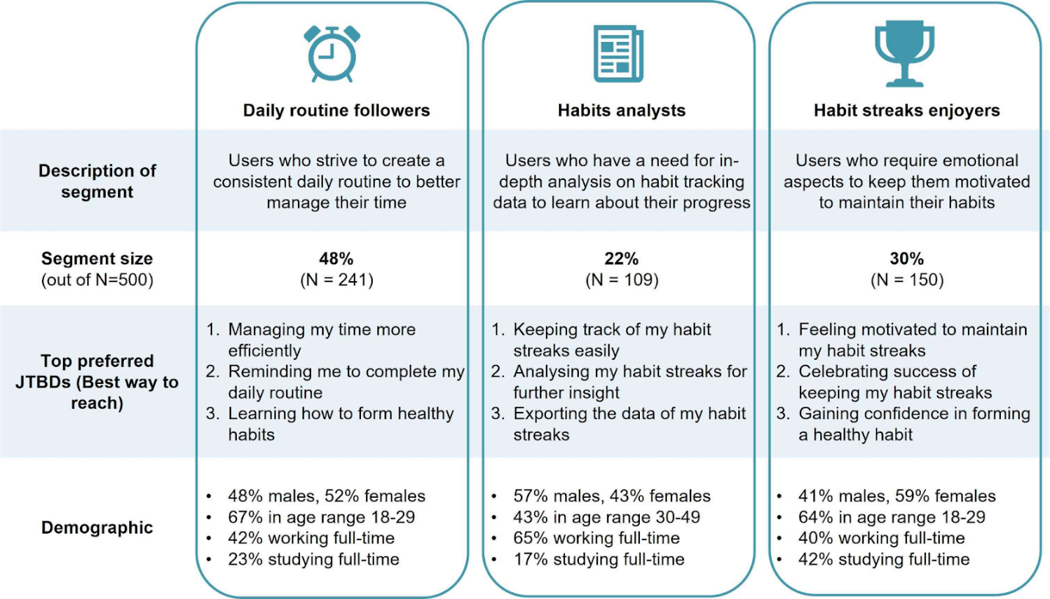

**UX!!!**



Examples of how things must be clear what is in focus.

Reading is hard

**Develop your attention to detail**

* **Responsiveness — does it work at all screen sizes?**
* **Consistency — type styles, spacing, alignment**
* **Border radii**
* **Optical spacing & layout**

**What makes an interface feel good?**

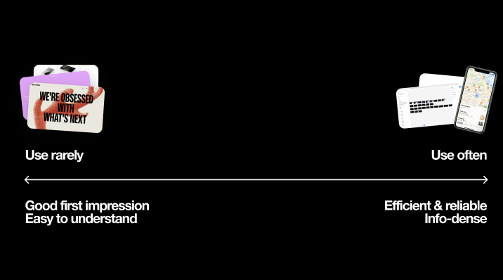

Even across these couple of different screens we just looked at, they're really optimizing for different things to achieve their goals.

One way we could think about those examples we just looked at is to group them by how often a user is expected to interact with it.

On one end we have interfaces that are rarely going to be seen. These are things like marketing websites or one-off projects, or an app that you only use once in a while. These interfaces need to make a really **good first impression because you won't be seeing it that much**. The interface needs to very quickly set the mood you're going for. That split-second visual impression is crucial to build trust and hold people's attention. These interfaces may have bold visuals and animations.

On the other end we have interfaces that are meant to be seen a lot. These are things like creative tools like Figma, utilities like maps and ChatGPT. These interfaces need to be super **fast and efficient** and reliable because you're using them so often. They can be packed with a lot of controls: There's not a lot of bold colors or animations unless it's used to communicate something.

Your clock project probably falls in the "use rarely" category. Most of your school projects will probably fall into the "use rarely" category since nobody's using it regularly. Even if it's supposed to be used often in theory, you still have to make a good first impression & be easy to understand since the real use of that project is adding it to your portfolio for the job search.

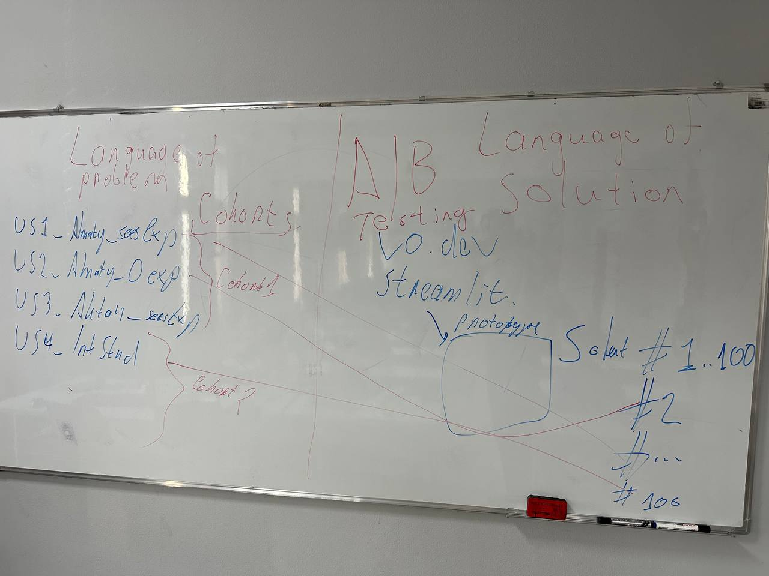

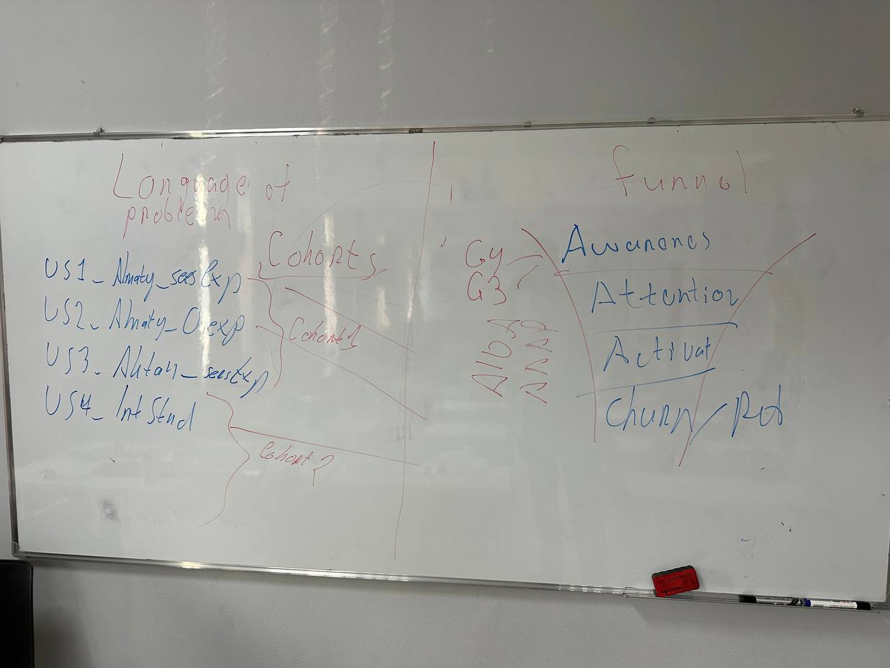

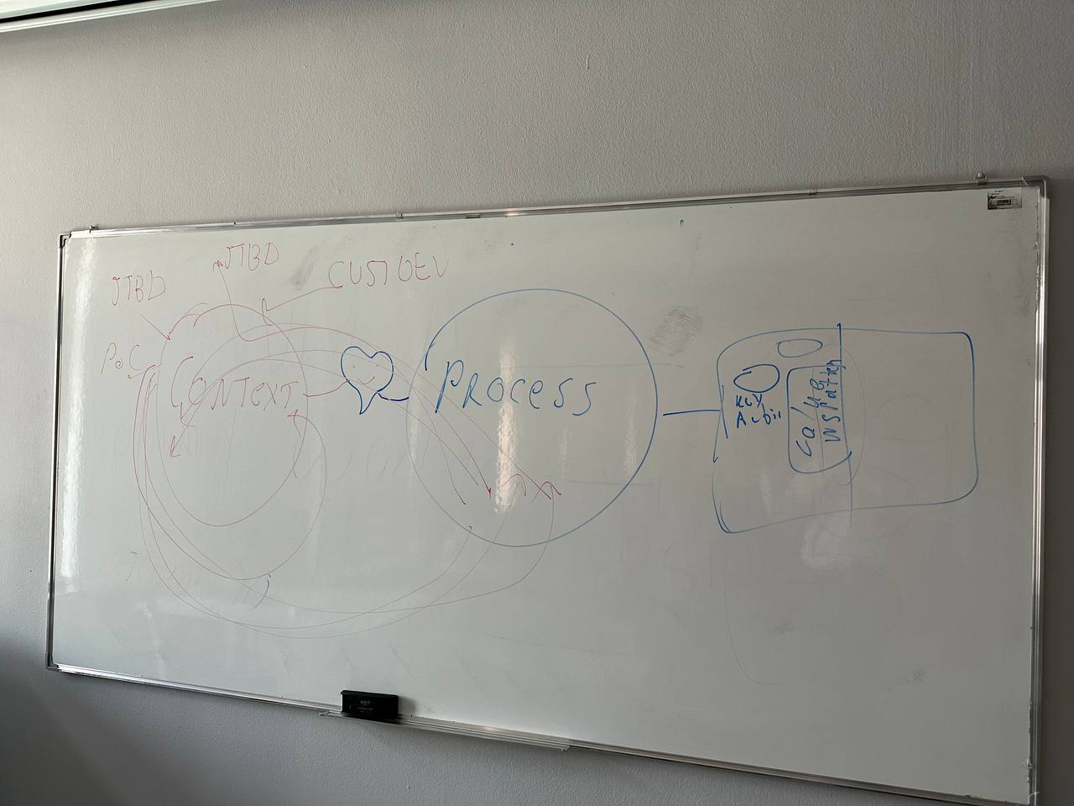

**Week 7.1: Startup financial modelling**

**Key Themes & Concepts:**

1. **ROI & Annualized ROI**
   * Why annualized ROI is a key metric for many investors.
   * Basic calculation: (Gain from Investment – Cost of Investment) / Cost of Investment × (365 / days invested).
2. **Investor Multipliers**
   * 50–80x “multipliers” used by certain VCs or angel investors.
   * Impact on valuation and how startups can pitch effectively.
3. **Budgeting & Forecasting**
   * Top-down vs. bottom-up forecasting.
   * Scenario planning: best case, conservative case.
4. **Discussion / Activity**
   * Students practice computing an annualized ROI for a hypothetical product.
   * Explore how focusing on 2–3 core metrics (growth, retention, revenue) can simplify strategic decisions.

**Example**

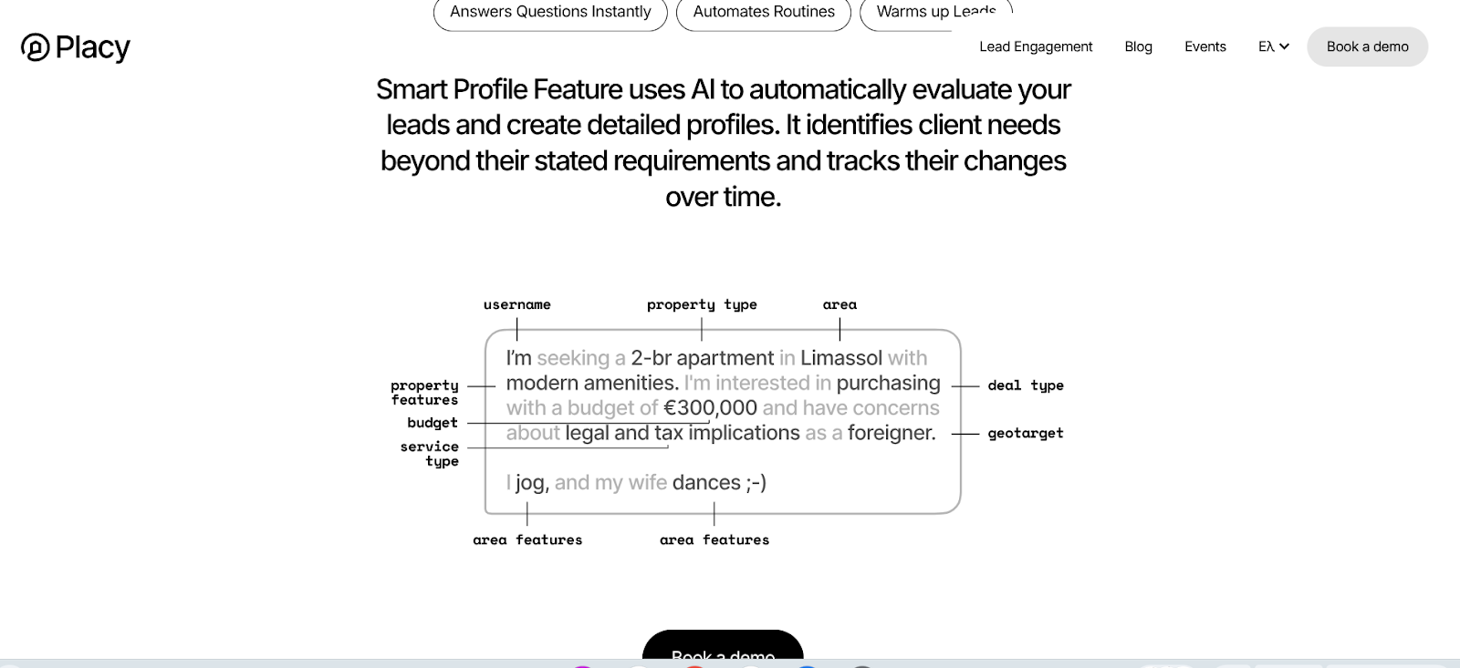

[**https://pro.placy.ai/**](https://pro.placy.ai/)

   •   Kazakhstan: The tech ecosystem is rapidly evolving, with significant growth in sectors like fintech and AI. Government-backed initiatives, such as [Astana Hub](https://astanahub.com/), provide support through grants and tax incentives to foster innovation.

   •   Türkiye: A robust tech landscape marked by successful startups scaling globally. Organizations like the [Technology Development Foundation of Turkey (TTGV)](https://en.wikipedia.org/wiki/Technology_Development_Foundation_of_Turkey) offer funding and support to tech ventures.

II. Key Concepts

1. Startup Cost Structure:

      •   Kazakhstan: Emphasis on leveraging government grants and incubators to offset high development costs.

      •   Türkiye: Access to a diverse talent pool and funding avenues, facilitating cost-effective operations.

2. Revenue Models & Unit Economics:

      •   Exploration of models like subscription services (e.g., SaaS platforms) and marketplaces.

      •   Understanding Customer Acquisition Cost (CAC) versus Customer Lifetime Value (LTV) in emerging markets.

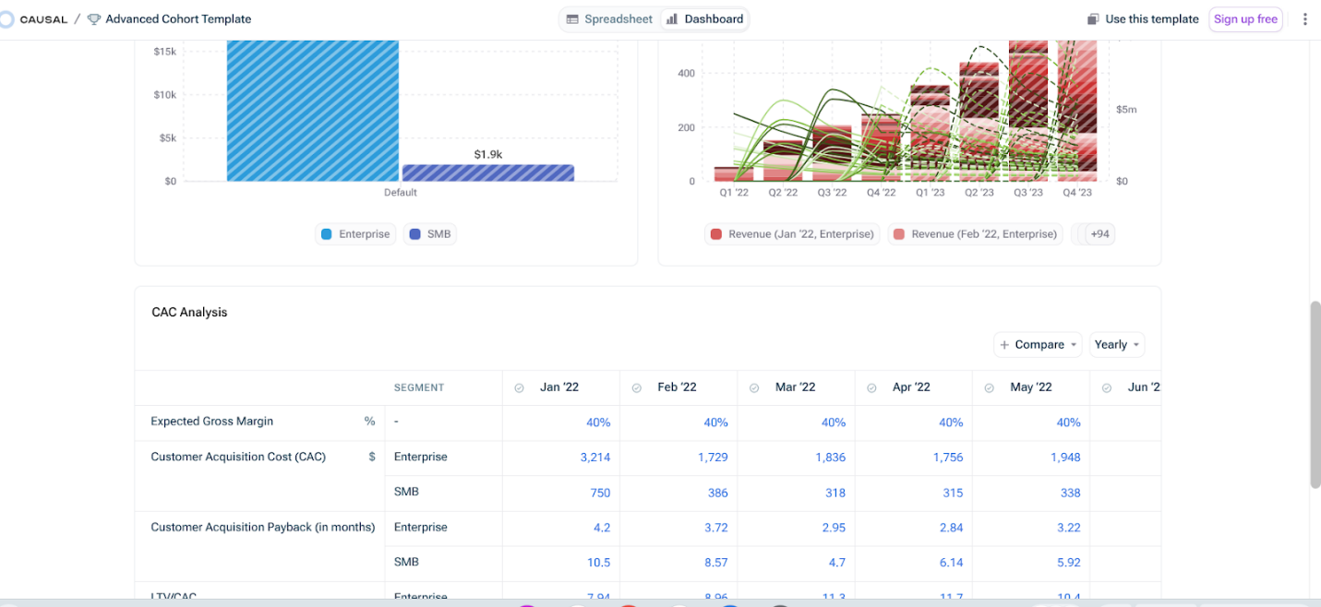

[**Cohort analysis**](https://my.causal.app/models/133001)

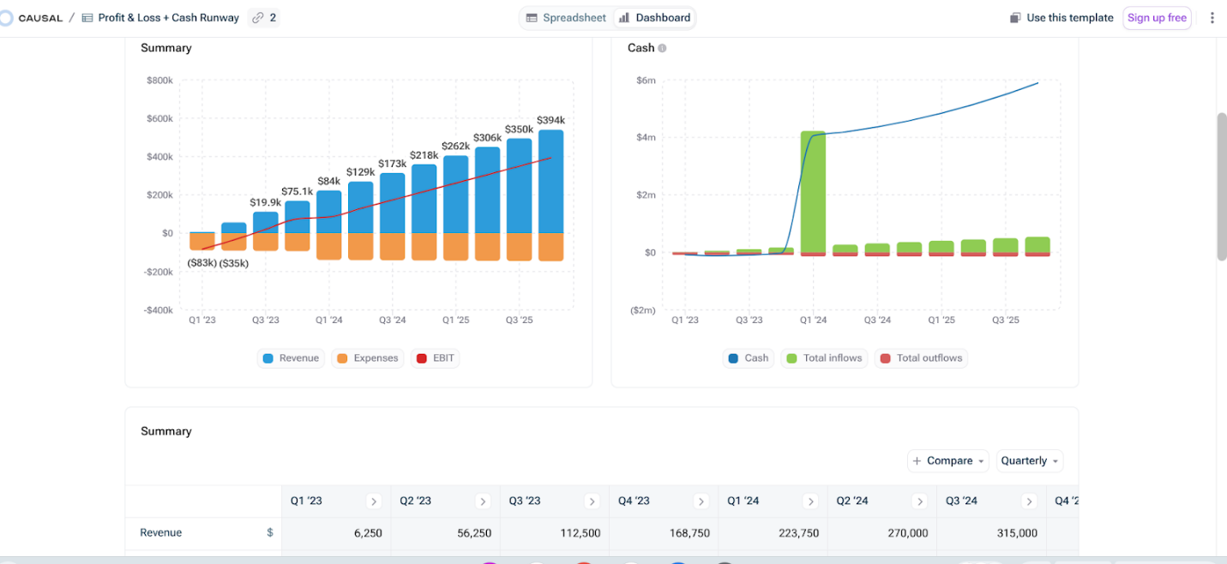

[**Startup P&L**](https://my.causal.app/models/89799)

3. Valuation Methods:

      •   Berkus Method: Assigns value based on qualitative factors, suitable for early-stage startups.

      •   Venture Capital (VC) Method: Focuses on expected returns and exit strategies.

4. Funding Sources:

      •   Kazakhstan: Opportunities through [Astana Hub](https://astanahub.com/).

      •   Türkiye: Support from entities like [TTGV](https://en.wikipedia.org/wiki/Technology_Development_Foundation_of_Turkey) and various venture capital firms.

**STARTUP VALUATION**

**We must use MULTIPLIER.**

**Example multiplier for:**

**Oil and gas - 10 years**

**Telecom - 7 years**

**SaaS - 7-10 years**

**AI Agents business - 10 - 50 years.**

IV. Resources & Templates

   •   Financial Modeling Tools:

      •   [Causal’s Startup Financial Model Templates](https://www.causal.app/templates) – Offers a variety of templates tailored for startups.

   •   Valuation Method Guides:

      •   [Startup Valuation Methods Presentation](https://www.slideshare.net/slideshow/startup-valuation-136631907/136631907) – Provides insights into various valuation techniques.

   •   Local Funding Opportunities:

      •   [Astana Hub Programs](https://astanahub.com/en/service/) – Details on grants and support available for Kazakhstani startups.

      •   [TTGV Initiatives](https://en.wikipedia.org/wiki/Technology_Development_Foundation_of_Turkey) – Information on programs supporting tech innovation in Türkiye.

**Week 7.2: Finance & Accounting Overview**

Key Themes & Concepts

1. **Basic Financial Statements**
   * Income statement, balance sheet, cash flow statement.
   * Key ratios (profit margin, current ratio, etc.).
2. **Budgeting & Investment Decisions**
   * Capital budgeting, ROI calculations.
   * Trade-offs between risk and return.
3. **Relevance for IS Professionals**
   * Aligning IT projects with financial objectives.
   * Justifying tech investments to non-technical stakeholders.
4. **Discussion / Activity**
   * **Midterm Exam** or **Project Check-in** focusing on applying financial concepts to a simple business scenario.

Readings & References

* **Pride et al.**, Ch. 17 (Financial Management)
* Basic accounting/finance tutorials (KBTU library resources)

Example

<https://docs.google.com/spreadsheets/d/13iSeQgBORYJUNxmhlUheVf6tUbsA40oZEDIR1s4OJ3A/htmlview>

**Lecture 8: AI & Innovation — RAG, Assistants, Open Source**

Key Themes & Concepts:

1. RAG (Retrieval-Augmented Generation)
   * Basics: hooking LLMs into external knowledge sources for more accurate, up-to-date answers.
   * [RAG Guide](https://docs.mistral.ai/guides/rag/)
2. OpenAI Assistants Platform
   * Overview of agent-based systems.
   * Potential use cases for product management, data analytics, or prototypes.
3. Requirements Engineering (RE)
   * Basic principles: scoping requirements, modeling processes, documenting changes.
   * [GERE-R3A GitHub](https://github.com/JulianFrattini/gere-r3a) for RE diagrams and open-source solutions.

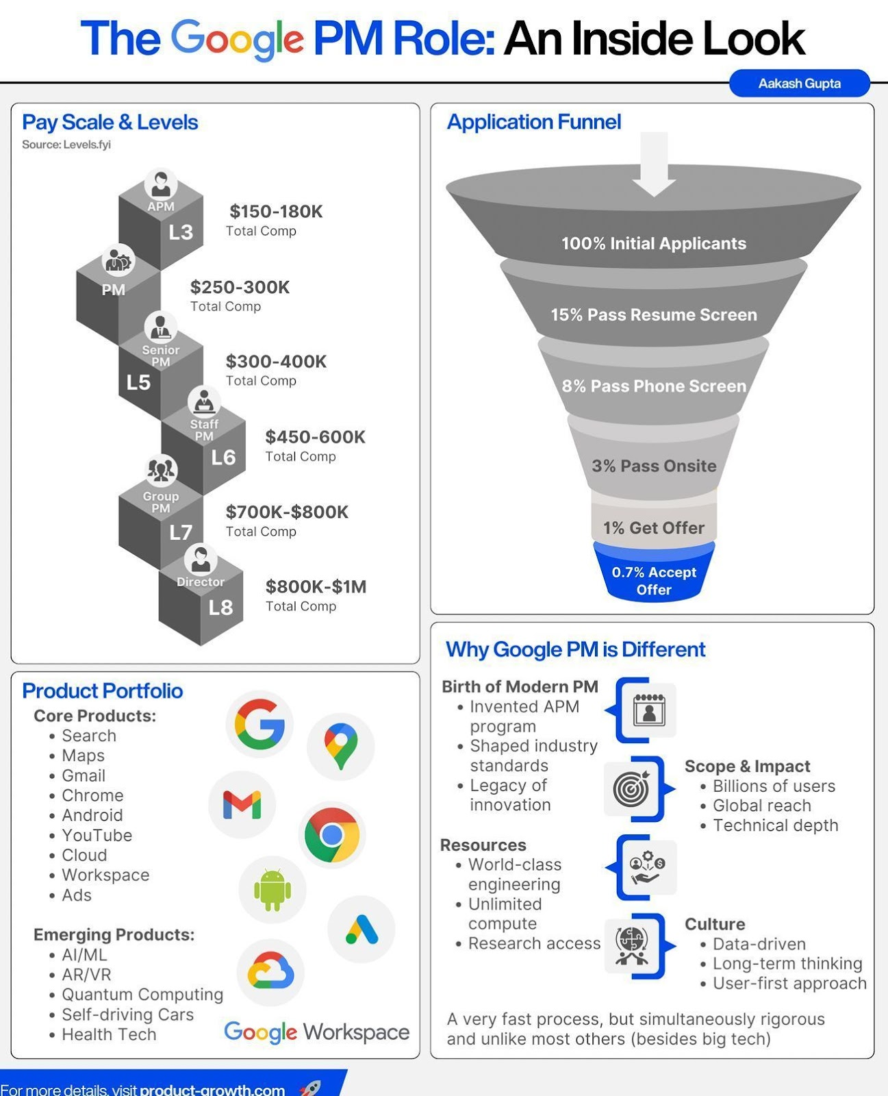

The real billion dollar opportunity in **SaaS is this:**

1. Unbundle SaaS businesses like Salesforce into many verticals (vertical > horizontal)
2. Clone and make 100% feature complete (not 80%)
3. Move business model to pay-per-usage over monthly SaaS (many people are sick of monthly)
4. Make the product & brand delightful (much of SaaS is soulless)
5. Use internet audiences, b2b creators, community to power distribution
6. 95% discount (not 90%)
7. Add each software to a holding company to compete with Salesforce, Adobe etc...

Most of these SaaS businesses can be spun up for under $50,000 thanks to AI and offshoring.

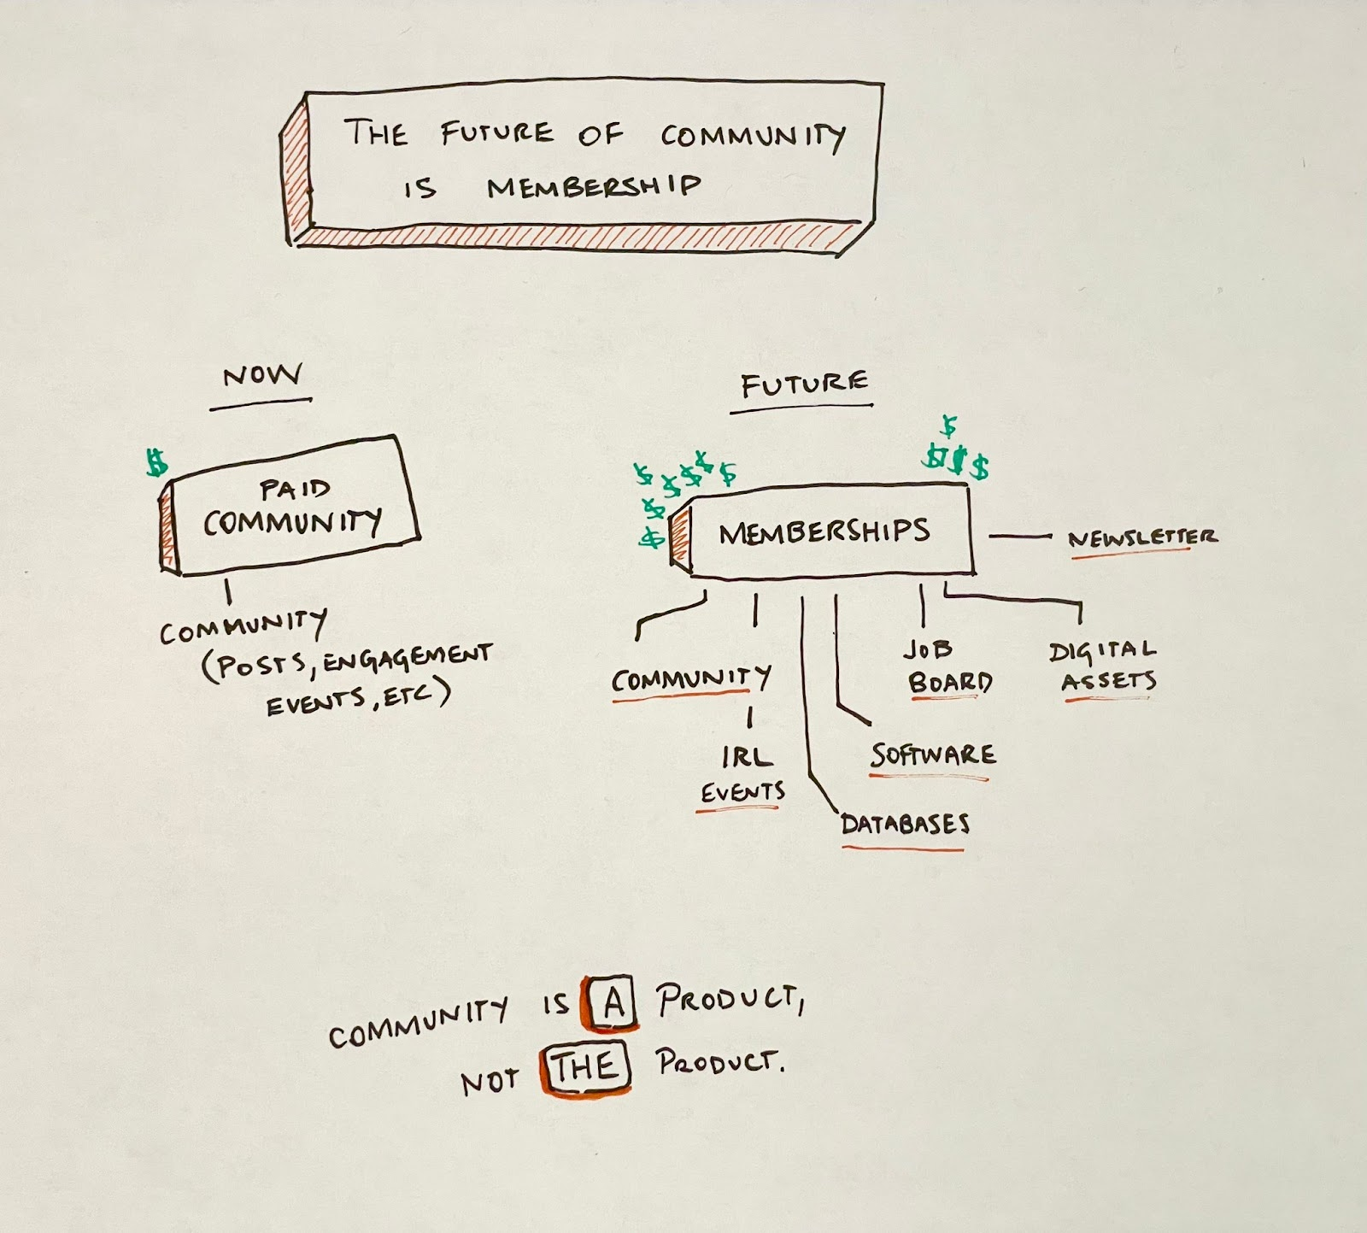

**1. Community**

The team is usually a community manager or a founder + community manager

A membership includes things like:

1. Community
2. Paid newsletter
3. Discounts & deals
4. IRL events
5. Software
6. Job boards
7. Digital assets (templates, resources etc).
8. Etc

The team is usually founder, community manager, content team, product team.

**Be Realistic**

Writing a blog = 1 day?

Research = 2 days Writing/Editing = 2 days

Admin = 0.25 days Social/Go To Market = 0.5 days

Writing a technical blog = 4.75 days

CREW AI <https://www.crewai.com/>

<https://www.harvey.ai/>

Pleep.AI (pleep.app)

BIG IDEAS [REPORT 2025!!](https://research.ark-invest.com/hubfs/1_Download_Files_ARK-Invest/Big_Ideas/ARK%20Invest%20Big%20Ideas%202025.pdf)

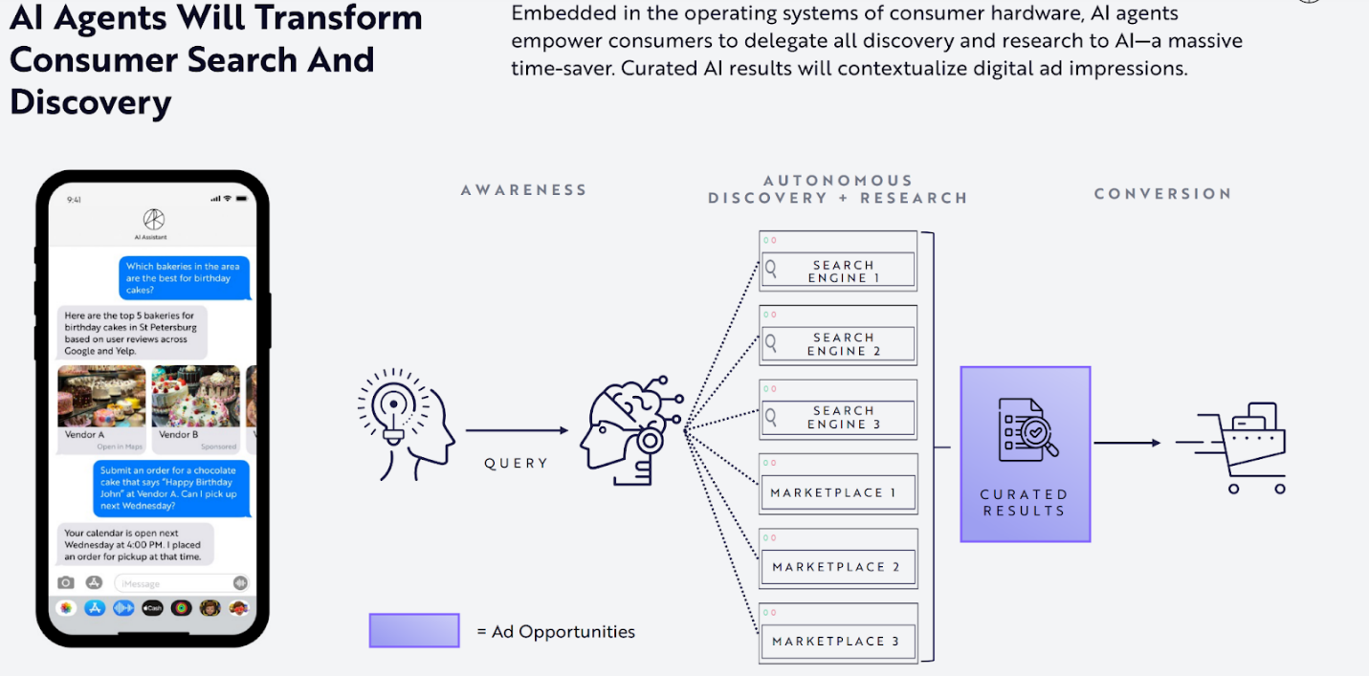

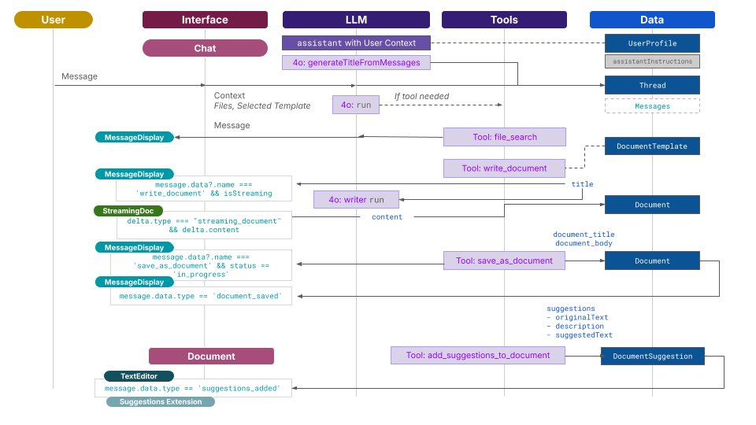

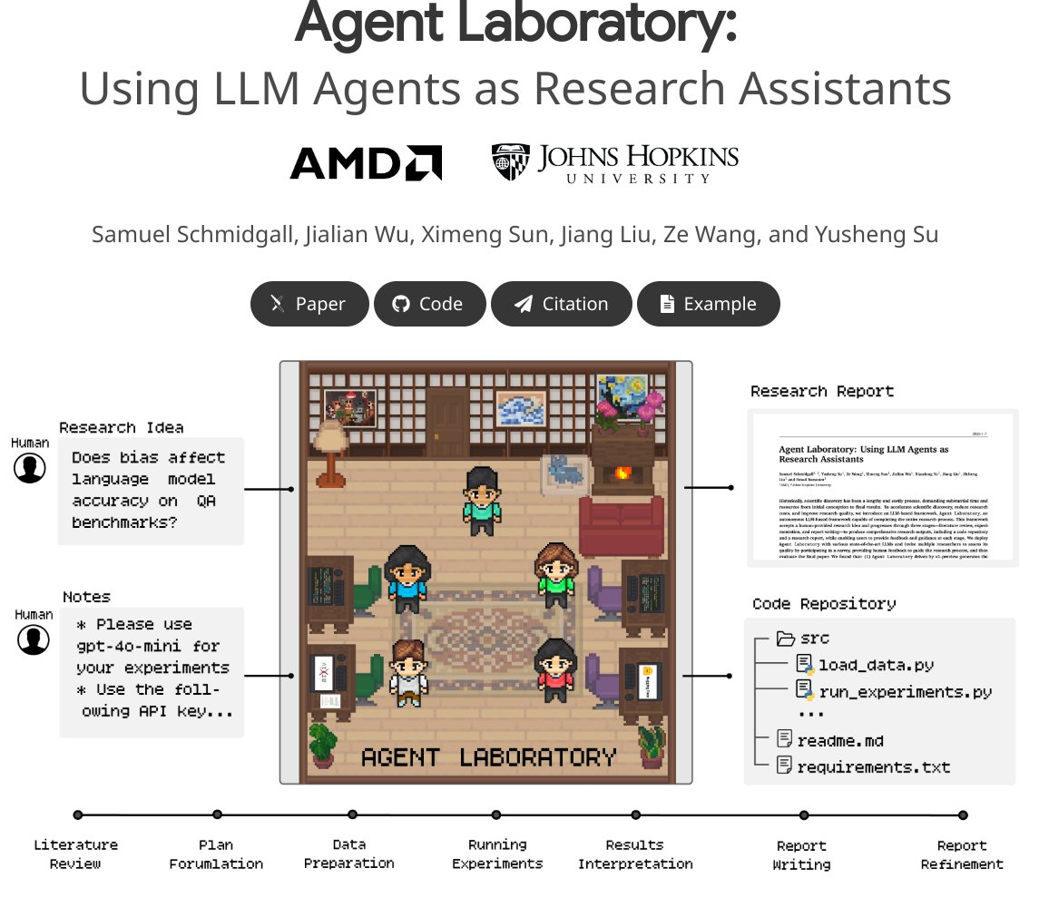

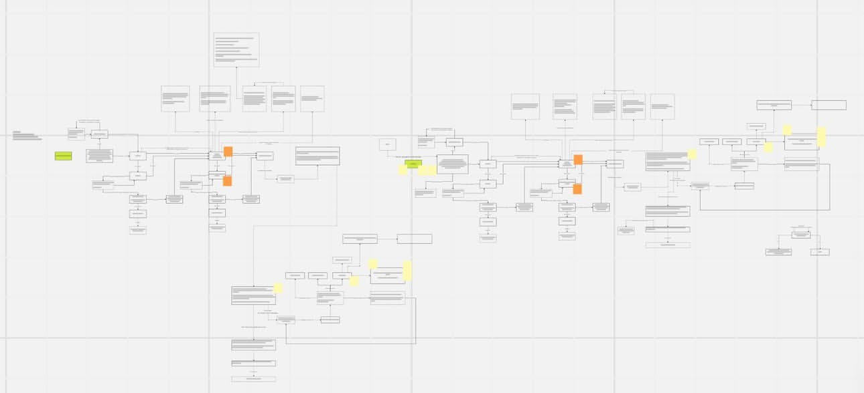

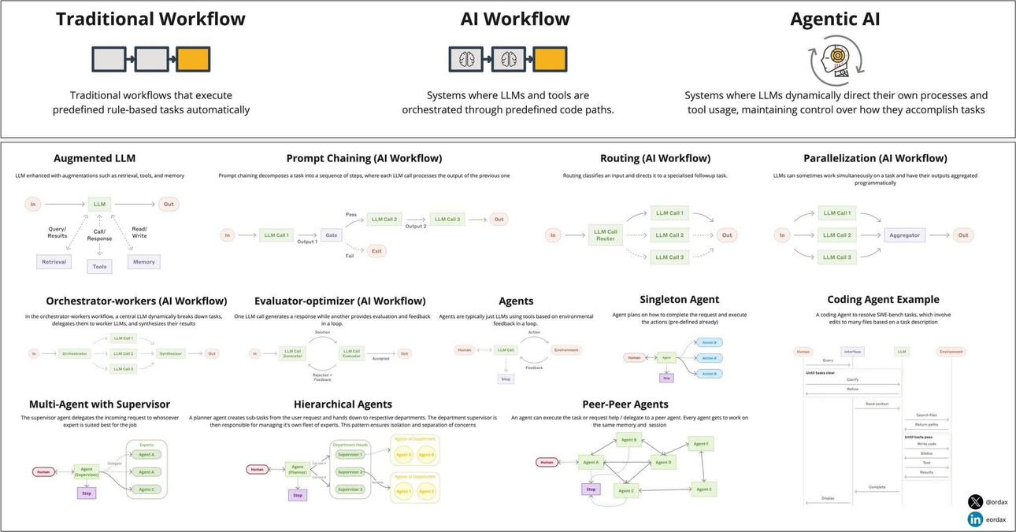

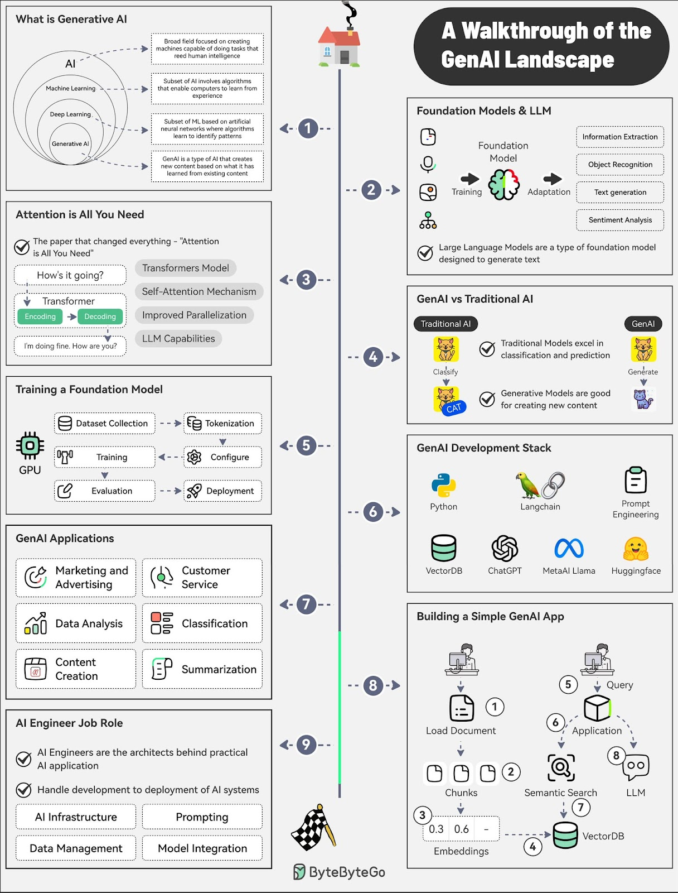

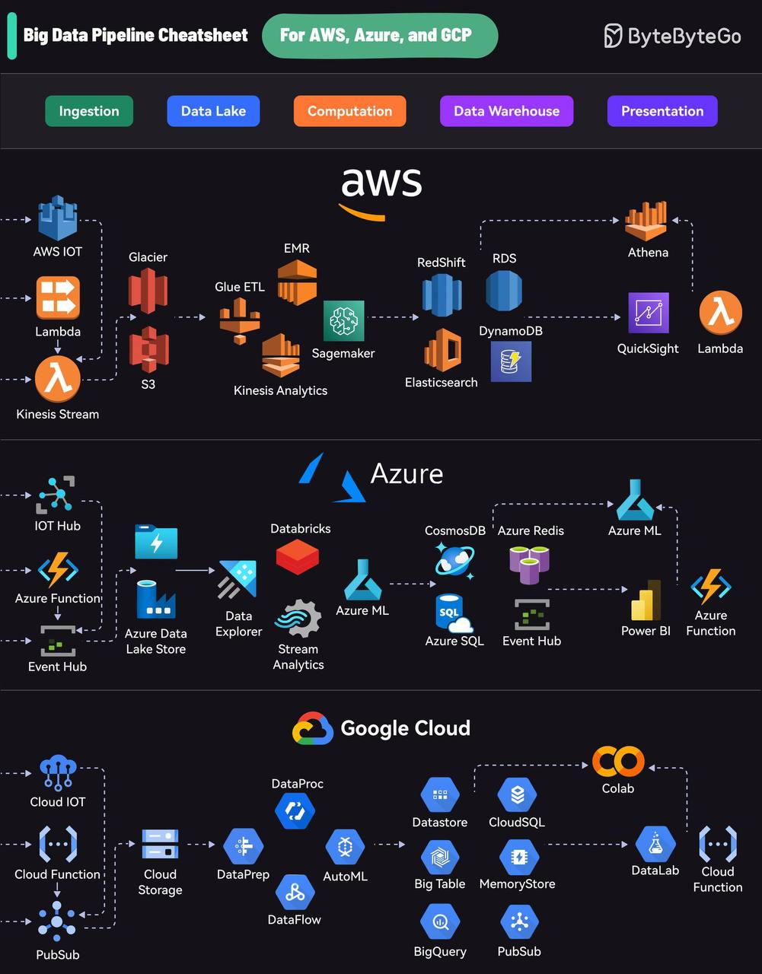

Example calculations of EBITDA / investments ROI

DEBIT

150 000 monthly - MRR monthly recurring revenue

CREDIT

22 000 000 apartment purchase - CAPEX

100 000 KZT - OPEX

Utilities - OPEX

**OPPORTUNITY COST**

Pension fund 12%

Deposit Halyk 14%

Deposit Kaspi 17%

**NPV**

12 лет - ROI - 0.

Квартира = 44 ляма. С учетом инфл 20% - 38 лямов + стоимость квартиры

vs

22*17%*12=45    / с учетом инфляции 20% - 39 лямов

Vs NASDAQ

* 50 лямов
* 50 - 39 лямов = 11 лямов

**Valuation**

MRR * 12 (ARR) * X (multiplier) = 11000 * 12 * 50 = 6 600 000

150 000 USD - investor, purchase 4.8

Pleep

12000 * 12 * 50 = 7 200 000 USD

7200 000

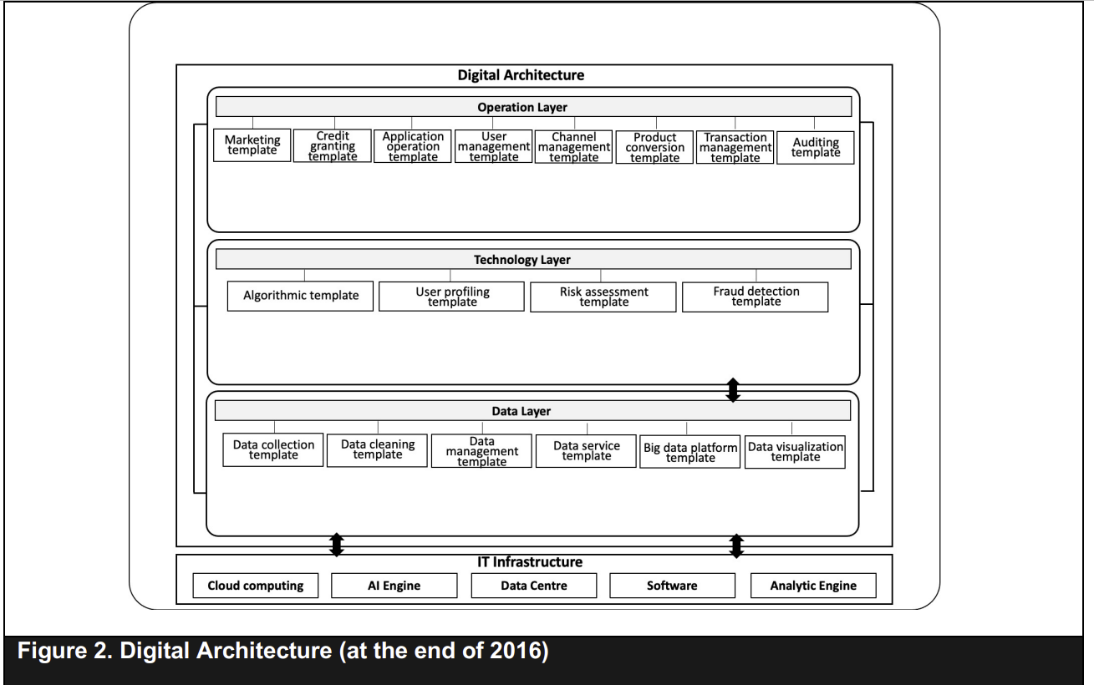

**ORiginal paper** <https://pubsonline.informs.org/doi/epdf/10.1287/isre.2021.1057>

DIGITAL business VS

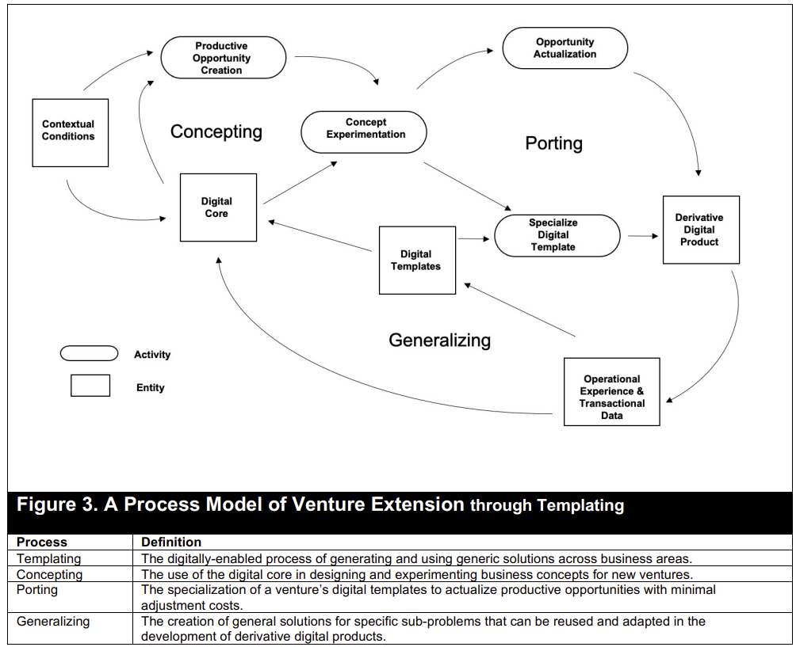

**VS Traditional business**

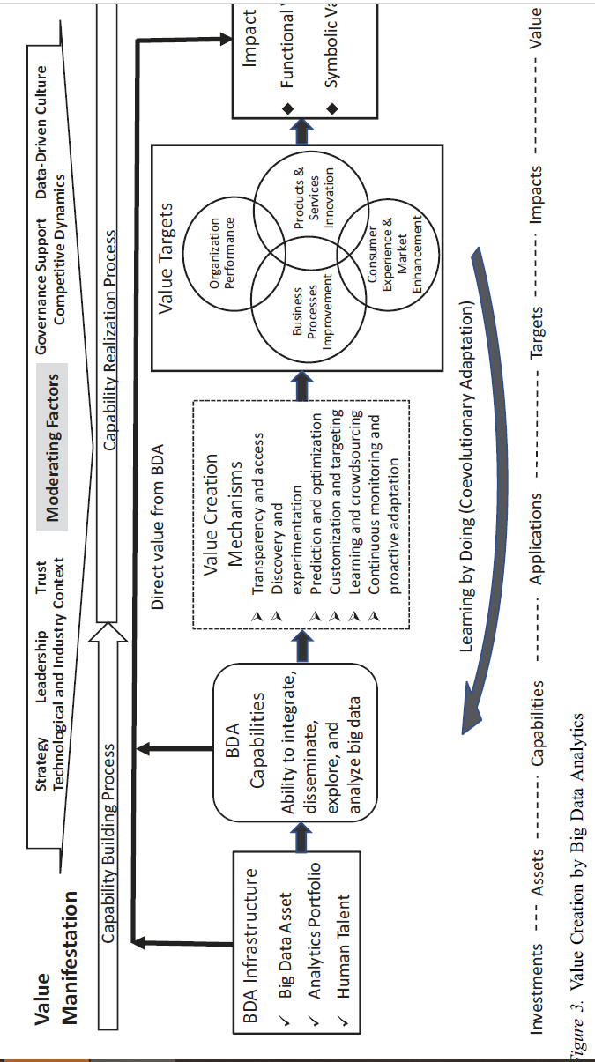

**Frontiers of digital innovation paper**

<https://pubsonline.informs.org/doi/full/10.1287/isre.2024.editorial.v35.n4>

[AI Interfaces Of The Future | Design Review](https://www.youtube.com/watch?v=DBhSfROq3wU)

How to do SIS 2 BERT NLP

<https://colab.research.google.com/github/tensorflow/text/blob/master/docs/tutorials/classify_text_with_bert.ipynb#scrollTo=_XgTpm9ZxoN9>  recommended lab to follow

<https://www.cloudskillsboost.google/course_templates/538/video/489216>  optional video course

<https://huggingface.co/blog/bert-101>?  Important article

<https://www.f6s.com/>

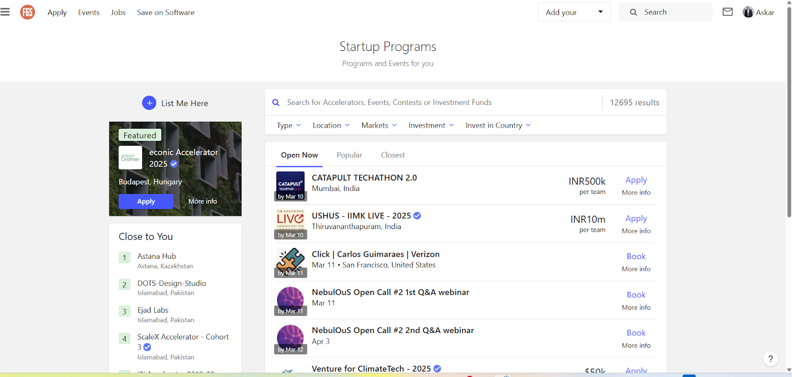 <https://www.f6s.com/>

Week 9. Analyzing Citix.me based on Digital Core theory

**Tesla** [**valuation**](https://l.facebook.com/l.php?u=https%3A%2F%2Fpages.stern.nyu.edu%2F~adamodar%2Fpc%2Fblog%2FTeslaJan2025DIY.xlsx%3Ffbclid%3DIwZXh0bgNhZW0CMTAAAR1tDi7eI9wb3FxKWlmmbLtShLE7aJH-eoY4WW0jDiVOFBl8T2W3MwCTdhI_aem_mtwV69yis4QwXqpsB8UcsA&h=AT3U8rQjijvL8K0J7aKLCcs84zwq8fdfl6h-CuxptFDcvVSNKGbu1FlOk5t0v1mK6GgJ2TjOXHYjNEtt1B4BObMnidm-PsF0fffGpeM5oEMakOjmz8khjPsxS33x1UAUAWX7Vd06SIZItx29&__tn__=R%5d-R&c%5b0%5d=AT1pMlDtIyBxoic_2ASEnfE4wXZ9hXIumQhqR-YGv9RLvESIO1GY1iVLPP6iFInwUn1i52uKvYExUojmEK3KCsgCtmoIU1SHB02SxBssNfYS_J6rQSiHvynP2ygh4tczc6qPZqv5I0nDM_tXrWfNQDn6IJlhVlpyM_aPLtKeSRLeoQ)

[**https://www.linkedin.com/pulse/investing-politics-globalization-backlash-disruption-aswath-damodaran-rqexc/**](https://www.linkedin.com/pulse/investing-politics-globalization-backlash-disruption-aswath-damodaran-rqexc/)

**Part 1: Jimmy Huang et al.’s Theory of Digital Core & Templating**

Key Components ([1](https://pubsonline.informs.org/doi/10.1287/isre.2021.1057)[3](https://scispace.com/pdf/growing-on-steroids-rapidly-scaling-the-user-base-of-digital-3faltvoykt.pdf)):

1. Digital Core:
   * Definition: A foundational technology (e.g., platform, algorithm, IoT system) enabling scalable value creation.
   * Example: Citix’s smartboards act as a digital core, integrating sensors, data analytics, and cloud connectivity.
   * *Visual: Diagram of digital core layers (hardware, data processing, application)*
2. Templating Mechanisms ([1](https://pubsonline.informs.org/doi/10.1287/isre.2021.1057)[2](https://dl.acm.org/doi/abs/10.1287/isre.2021.1057)):
   * Hard Templating: Replicable physical/digital infrastructure (e.g., Citix’s standardized smartboard hardware).
   * Sacrificial Templating: Adaptable software layers (e.g., Citix Panel’s API for third-party integrations).
   * *Visual: Side-by-side comparison of hard vs. sacrificial templates*
3. Extension Processes ([1](https://pubsonline.informs.org/doi/10.1287/isre.2021.1057)):
   * Concepting: Identifying reusable solutions (e.g., Citix’s traffic optimization algorithms for MENA cities).
   * Generalizing: Abstracting solutions for cross-market use (e.g., adapting Almaty’s pedestrian data models to Istanbul).
   * Porting: Deploying templates to new contexts (e.g., smartboard installations in Astana’s public transit hubs).
   * *Visual: Flowchart of concepting → generalizing → porting*

Part 2: Citix.me’s Application of Huang’s Theory

Digital Core in Action ([3](https://scispace.com/pdf/growing-on-steroids-rapidly-scaling-the-user-base-of-digital-3faltvoykt.pdf)):

* Infrastructure Layer: IoT-enabled smartboards collect real-time urban data.
* Data Layer: Proprietary analytics transform raw data into traffic/pedestrian insights.
* Application Layer: Citix Panel allows municipalities to manage infrastructure remotely.
* *Visual: Screenshot of Citix Panel dashboard with live traffic metrics*

Templating Successes ([1](https://pubsonline.informs.org/doi/10.1287/isre.2021.1057)[3](https://scispace.com/pdf/growing-on-steroids-rapidly-scaling-the-user-base-of-digital-3faltvoykt.pdf)):

* Cost Reduction: Hard templating cut smartboard production costs by 40% post-2022.
* Scalability: Sacrificial templating enabled rapid API integrations with UAE’s smart city initiatives.

Part 3: Challenges Post-IPO

Templating Limitations ([1](https://pubsonline.informs.org/doi/10.1287/isre.2021.1057)):

* Overstandardization: Hard templating caused compatibility issues with Astana’s legacy infrastructure.
* Concepting Gaps: MENA traffic patterns diverged from Kazakh models, requiring costly rework.

Digital Core Constraints:

* Data Silos: Analytics layer couldn’t integrate with third-party urban planning tools.
* Porting Delays: Slow adoption in Oman due to regulatory barriers unaddressed in templates.
* *Visual: Venn diagram of technical vs. market readiness challenges*

Part 4: Class Discussion & Takeaways

Discussion Prompts:

1. Did templating prioritize scalability over Citix’s profitability?
2. How might Huang’s “porting” process be redefined for regulatory diversity?

Teaching Takeaways:

* Digital Core ≠ Product: It’s a dynamic architecture requiring continuous adaptation.
* Templating Trade-offs: Standardization sacrifices localization flexibility.
* IPO Realities: Public markets demand profitability proofs beyond technical innovation.

*Visual: Summary slide with key theory components and Citix case linkages*

Assigned Reading: Huang et al. (2021) *Extending Digital Ventures Through Templating*[1](https://pubsonline.informs.org/doi/10.1287/isre.2021.1057).  
Case Study Prep: Analyze Citix’s 2024 investor report for templating vs. profitability metrics.

Citix’s Financial Strategy & Post-IPO Challenges

*(Visual: Slide comparing Citix’s bond issuances vs. Air Astana’s IPO metrics)*

Part 1: Citix’s AIX Fundraising Journey

Pre-IPO Bond Issuances ():

1. 2023 Debt Offering:
   * Raised $10 million via 2-year bonds at 10.5% annual coupon[4](https://kz.kursiv.media/2023-06-09/skvr-citix-ff/).
   * Funds allocated to launch smartboards in Türkiye (100 units planned for 2023) and UAE/Saudi Arabia[4](https://kz.kursiv.media/2023-06-09/skvr-citix-ff/).
   * *Visual: Map of Citix’s 2023 expansion targets vs. actual deployments*
2. 2024 Follow-Up Bond:
   * Issued $20 million at 11% yield, part of a $100 million program[6](https://kz.kursiv.media/2024-04-04/lgtn-citixbonds/)[8](https://ffin.kz/news/35035-freedom-finance-global-provela-razmeschenie-obligatsiy-citix-ltd).
   * Focus on scaling Türkiye operations and entering Oman’s market[6](https://kz.kursiv.media/2024-04-04/lgtn-citixbonds/).
   * *Visual: Bond structure table (2023 vs. 2024 terms)*

Key Financial Metrics:

* Revenue: Projected 3 billion KZT (~$6.7 million) in 2023, targeting 7 billion KZT (~$15.6 million) by 2025[4](https://kz.kursiv.media/2023-06-09/skvr-citix-ff/).
* Debt Burden: Combined $30 million debt carries 10.8% weighted interest, requiring ~$3.24 million annual servicing[4](https://kz.kursiv.media/2023-06-09/skvr-citix-ff/)[6](https://kz.kursiv.media/2024-04-04/lgtn-citixbonds/).
* *Visual: Debt-to-revenue ratio chart (2023–2025 projections)*

Part 2: IPO Ambitions vs. Market Realities

Air Astana’s IPO Context ():

* Success Factors:
  + Raised $120 million on AIX/LSE in Feb 2024, with 56% retail investor participation[1](https://astanatimes.com/2024/02/air-astana-begins-trading-on-lse-aix-and-kase/).
  + Post-IPO valuation buoyed by 22-year profitability history and $223.4 million domestic demand[1](https://astanatimes.com/2024/02/air-astana-begins-trading-on-lse-aix-and-kase/)[7](https://aifc.kz/news/aifc-presents-analytical-report-on-capital-market-based-on-aix-exchange-activities/).
* Citix Contrast:
  + Reliant on high-yield bonds due to lack of profitability and unproven MENA expansion.
  + Absent from AIX’s 2024 equity leaders (Solidcore: 52%, Air Astana: 19% of trading volume)[2](https://aifc.kz/news/aix-presents-its-results-for-2024/).

AIX Debt Market Dynamics:

* 2024 Trends: Debt trading fell to 62% of AIX’s $1.3B turnover (vs. 78% in 2023)[2](https://aifc.kz/news/aix-presents-its-results-for-2024/).
* Citix’s Position: Bonds contribute to AIX’s $2.3B total debt raised since inception[3](https://aifc.kz/wp-content/uploads/2024/11/capital-markets-october-eng.pdf), but lack secondary market liquidity.
* *Visual: AIX’s 2024 trading pie chart (equity/debt/Citix share)*

Part 3: Profitability Hurdles Post-Fundraising

Cost Structure Pressures:

1. R&D Intensity: Developing blockchain-managed smartboards and IoT analytics strains margins.
2. Market Entry Costs: Türkiye/Oman setups require upfront CAPEX (e.g., $20M bond allocated to Türkiye logistics)[6](https://kz.kursiv.media/2024-04-04/lgtn-citixbonds/).
3. Coupon Drag: Debt servicing consumes ~48% of 2023 revenue (vs. Air Astana’s 12% EBITDA margin)[1](https://astanatimes.com/2024/02/air-astana-begins-trading-on-lse-aix-and-kase/)[4](https://kz.kursiv.media/2023-06-09/skvr-citix-ff/).

Operational Risks:

* Türkiye Delays: Only 5 smartboards deployed in Istanbul by 2023 vs. 100 planned[4](https://kz.kursiv.media/2023-06-09/skvr-citix-ff/).
* AdTech Competition: AIX’s 2024 report shows advertisers favoring equity-backed DOOH players like Halyk Bank (+33% share growth)[7](https://aifc.kz/news/aifc-presents-analytical-report-on-capital-market-based-on-aix-exchange-activities/).
* *Visual: Risk matrix (likelihood vs. impact of Citix’s challenges)*

Part 4: Teaching Takeaways

Debt vs. Equity Trade-Offs:

* Citix’s Choice: High-cost debt avoided equity dilution but limited growth capital ($30M raised vs. Air Astana’s $120M IPO).
* Investor Sentiment: AIX retail investors favor profitable incumbents (Air Astana) over speculative tech issuers[1](https://astanatimes.com/2024/02/air-astana-begins-trading-on-lse-aix-and-kase/)[7](https://aifc.kz/news/aifc-presents-analytical-report-on-capital-market-based-on-aix-exchange-activities/).

Critical Discussion Points:

1. Can Citix’s 11% bonds attract institutional buyers if MENA expansion underperforms?
2. Would an IPO (vs. bonds) better align with Huang’s templating theory for scaling?

Assignment:

* *Case Study*: Compare Citix’s 2023–2024 bond covenants with Air Astana’s IPO prospectus risk disclosures.

<https://kz.kursiv.media/2023-06-09/skvr-citix-ff/>

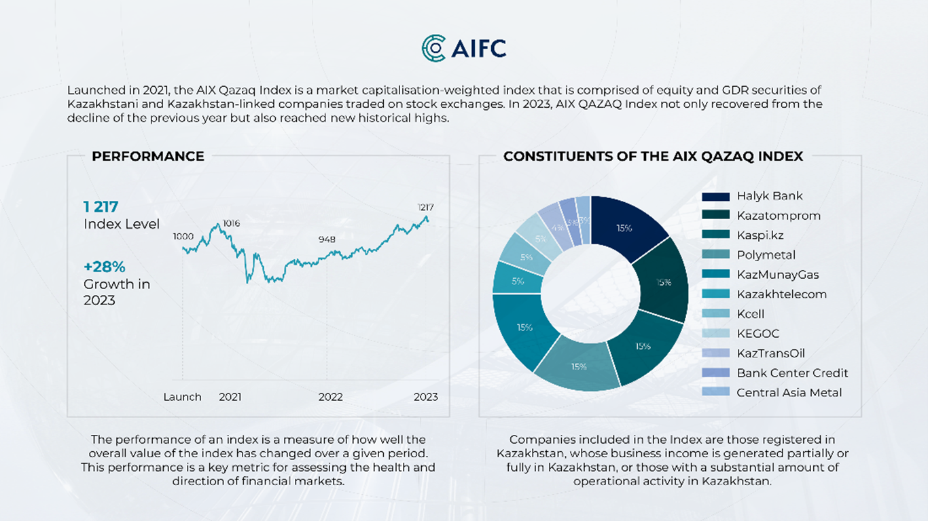

<https://oninvest.com/article/citix-privlecet-20-mln-na-rassirenie-biznesa-za-rubezom>

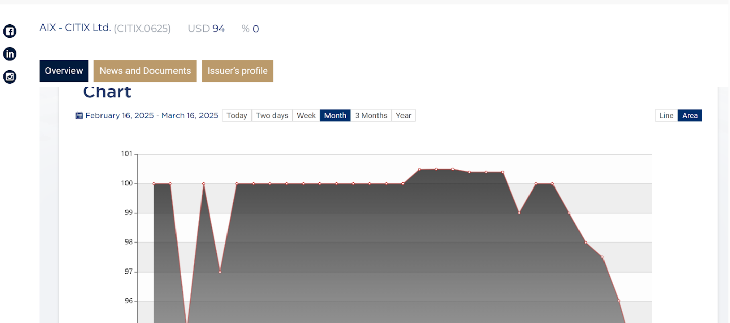

<https://aix.kz/issuers/citix-ltd-citix-0625/>

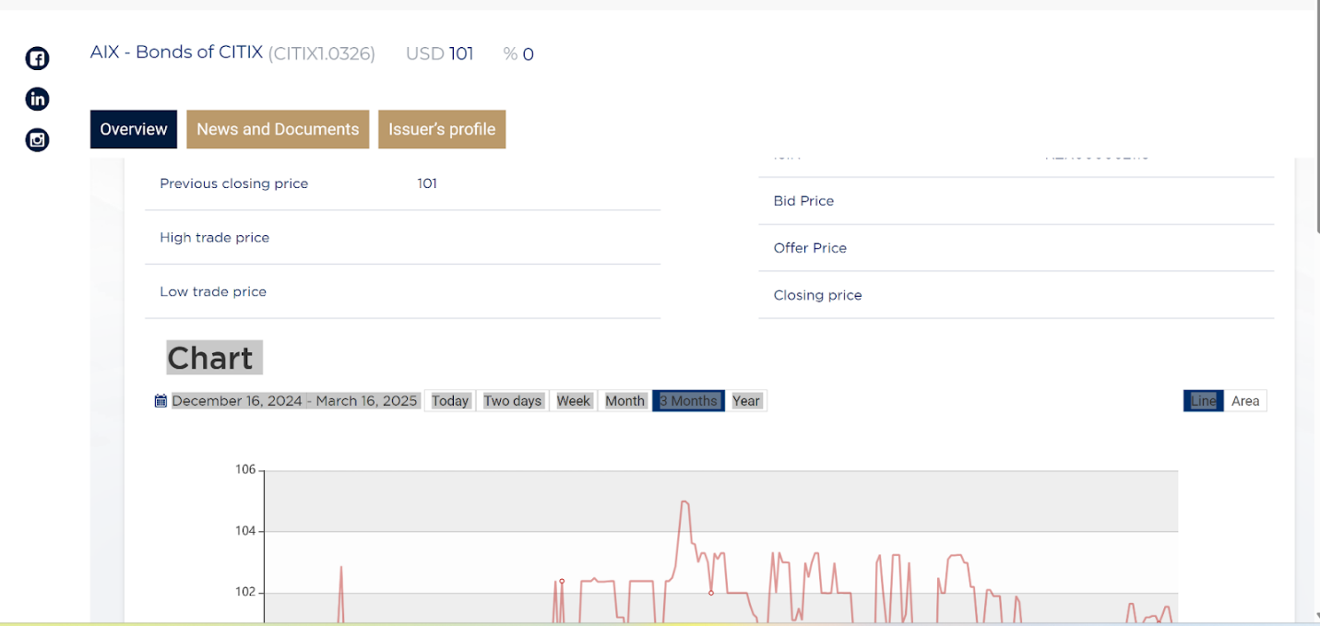

<https://aix.kz/issuers/citix-ltd-citix1-0326/>

**Week 10. HR and Legislation (Governance, law, compliance)**

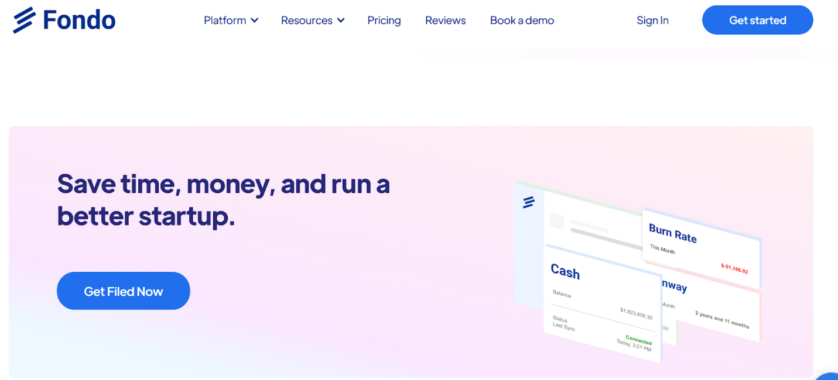

**Source** [**Fondo**](https://www.tryfondo.com/taxpass)**. Just raised 7 million USD**

Effective management of human resources and adherence to legislative frameworks are critical pillars of organizational success, particularly in technology-driven industries. This lecture explores strategic HR practices—including people profiling, persona identification, and psychological character management—and examines governance frameworks spanning sectors such as banking, aerospace, and agriculture in Kazakhstan.

Strategic Human Resource Management

Modern HR transcends administrative functions by aligning talent strategies with business objectives. Two prominent models illustrate this shift: the *talent management model* and the *agile HR model*. The former emphasizes succession planning, career development, and performance management to build a sustainable workforce with skills aligned to long-term goals[1](https://www.betterworks.com/magazine/strategic-human-resource-management/). For instance, organizations adopting this model prioritize reducing turnover by creating clear growth pathways for employees. Conversely, the *agile HR model* borrows from tech-industry practices, using iterative processes like scrum teams and continuous feedback to adapt HR practices dynamically[1](https://www.betterworks.com/magazine/strategic-human-resource-management/). This approach suits industries like software development, where market demands shift rapidly.

A key tool in HR strategy is personality profiling, which enables managers to tailor interactions based on psychological traits. Frameworks like DiSC (Dominance, Influence, Steadiness, Conscientiousness) help identify communication preferences, decision-making styles, and conflict-resolution approaches. For example, a salesperson using DiSC can adapt their pitch: emphasizing results for a "dominant" prospect or fostering collaboration with a "steadiness"-oriented client[2](https://www.linkedin.com/pulse/personality-profiling-gimmick-vital-tool-success-gilly). As Gilly of LinkedIn notes, profiling prevents hiring based solely on technical skills or personal bias, mitigating risks like groupthink and disengagement[2](https://www.linkedin.com/pulse/personality-profiling-gimmick-vital-tool-success-gilly). Myers-Briggs Type Indicator (MBTI) further classifies individuals into categories like *introverts* (detail-oriented but reserved) and *thinkers* (analytical, logic-driven)[4](https://www.linkedin.com/pulse/understanding-personality-types-management-styles-key-okoro-gqalf). Understanding these profiles allows managers to delegate tasks effectively—assigning data analysis to a "thinker" or team-building initiatives to a "socializer."

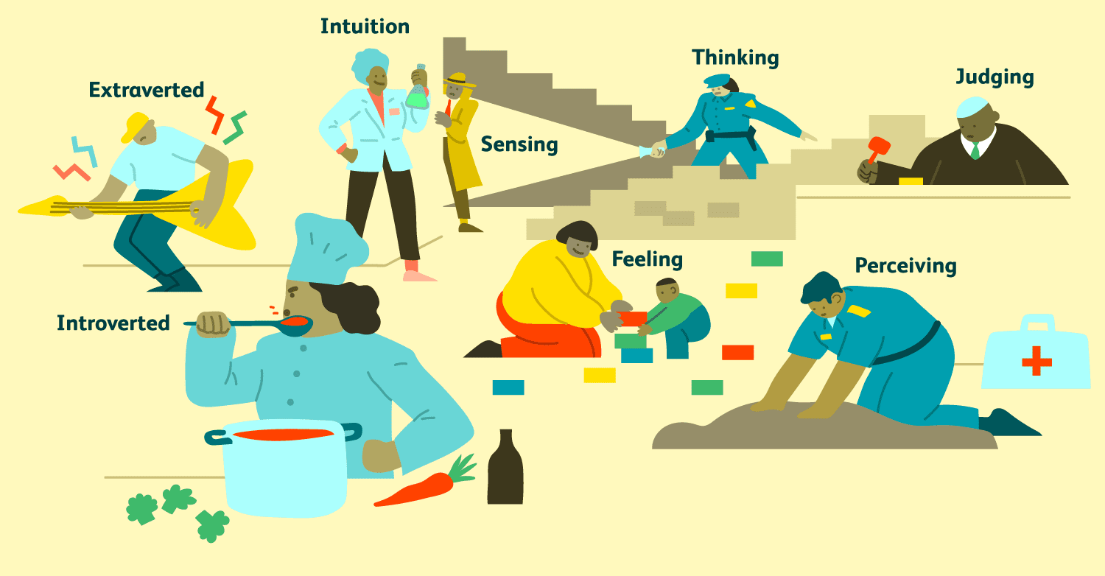

**Myers-Briggs Type Indicator (MBTI) profiling example**

**Key takeaway:**

1. **Listen to all your team mates (don’t interrupt)**
2. **Don’t make obvious mistakes in your products**
3. **Bear in  mind personalities when giving assignments**

Employee personas complement profiling by categorizing workforce motivations. Common personas include:

* Socializers: Collaborative individuals thriving in team environments (e.g., customer service roles)[3](https://www.achievers.com/blog/employee-personas/).
* Directors: Visionary leaders excelling in strategic roles (e.g., project managers)[3](https://www.achievers.com/blog/employee-personas/).
* Supporters: Empathetic team members fostering psychological safety (e.g., HR professionals)[3](https://www.achievers.com/blog/employee-personas/).

By aligning roles, incentives, and communication styles to these personas, managers optimize productivity. For instance, a "director" persona may prefer autonomy in decision-making, while a "supporter" might value regular check-ins to address team morale.

As renowned organizational psychologist Edgar Schein noted, "The art of management is fundamentally the art of understanding human behavior in complex organizational settings" (Schein, 2010).

**Psychological Personas in Information Systems**

|  |  |  |  |
| --- | --- | --- | --- |
| **Persona Type** | **Key Characteristics** | **Ideal Work Environments** | **Potential Challenges** |
| The Analyst | Systematic thinkers are the backbone of methodical problem-solving. They excel in breaking down complex problems into structured, manageable components. Their approach is characterized by precision, attention to detail, and a logical methodology that ensures thorough and accurate analysis. These professionals prioritize accuracy over speed, carefully examining every aspect of a problem before developing a comprehensive solution. | Data management roles provide the perfect environment for analysts. In these positions, they can apply their systematic thinking to organize, interpret, and derive insights from complex datasets. Quality assurance teams also benefit from their meticulous nature, as analysts can identify subtle discrepancies that others might overlook. Technical documentation and cybersecurity divisions particularly value their ability to create precise, comprehensive reports and identify potential system vulnerabilities. | Analysts face significant challenges when confronted with creative or ambiguous tasks. Their preference for structured approaches can become a limitation in rapidly changing environments. They may struggle with brainstorming sessions that require out-of-the-box thinking and can become overly focused on minor details, potentially missing broader strategic perspectives. Their resistance to change can slow down innovation and make it difficult to adapt to new methodologies or technologies. |
| The Innovator | Creative problem solvers represent the dynamic force of organizational innovation. These individuals possess an extraordinary ability to challenge existing paradigms and envision unconventional solutions. Their cognitive flexibility allows them to connect seemingly unrelated concepts, generating breakthrough ideas that can transform organizational capabilities. They thrive on intellectual stimulation and possess an innate curiosity that drives continuous exploration and learning. | Research and development departments are the natural habitat for innovators. These environments provide the intellectual freedom and resources necessary for exploring cutting-edge concepts. Strategic planning teams benefit from their ability to anticipate future trends and develop forward-thinking strategies. Product design and emerging technology sectors offer the perfect playground for their creative problem-solving skills, allowing them to push technological boundaries and introduce groundbreaking solutions. | Innovators often struggle with the practical implementation of their ideas. Their enthusiasm for conceptual thinking can lead to challenges in translating innovative concepts into actionable plans. They may be perceived as disruptive by more conservative team members and can become frustrated with organizational bureaucracy. Their difficulty in adhering to strict protocols and tendency to overlook implementation details can create friction within traditional organizational structures. |
| The Collaborator | Masters of interpersonal dynamics, collaborators are the social architects of organizational success. They possess an exceptional ability to build and maintain relationships, creating harmonious work environments that facilitate team cohesion and collective achievement. Their emotional intelligence allows them to navigate complex social landscapes, mediate conflicts, and create inclusive communication channels that bridge diverse perspectives. | Project management roles are ideal for collaborators, as they can leverage their communication skills to coordinate complex team efforts. Cross-functional team leadership positions allow them to demonstrate their ability to unite diverse groups towards common objectives. Client relationship management requires their empathetic approach, enabling them to build strong, trust-based connections. Training and development roles provide opportunities to nurture organizational talent and facilitate learning experiences. | While collaborators excel in building relationships, they often struggle with making difficult decisions that might create interpersonal tension. Their desire to maintain group harmony can lead to avoiding necessary confrontations and potentially compromising organizational effectiveness. They may find it challenging to make independent decisions, often seeking consensus even in situations requiring swift, decisive action. Their tendency to prioritize relationships over immediate outcomes can sometimes slow down critical organizational processes. |

The regulatory landscape in Kazakhstan represents a sophisticated approach to technological governance, balancing global standards with local industry needs. Understanding these frameworks is crucial for information systems professionals navigating complex organizational environments.

**Regulatory Frameworks in Kazakhstan**

|  |  |  |  |
| --- | --- | --- | --- |
| **Industry** | **Regulatory Focus** | **Regulatory Body** | **Primary Compliance Requirements** |
| Banking | The banking sector's regulatory framework represents a sophisticated approach to technological governance and financial security. It encompasses comprehensive strategies for protecting sensitive financial data, ensuring cybersecurity, and maintaining the integrity of financial systems. These regulations are designed to create a robust ecosystem that balances technological innovation with stringent security protocols. | National Bank of Kazakhstan serves as the primary regulatory authority, developing and implementing advanced technological and security standards for the financial sector. Their approach goes beyond traditional regulatory oversight, actively creating frameworks that support technological innovation while protecting stakeholder interests. | Compliance requirements in the banking sector are multifaceted and comprehensive. Financial institutions must implement advanced encryption technologies to protect customer data. Regular security audits are mandatory to identify and mitigate potential vulnerabilities. Transparency in data handling is crucial, with clear protocols for managing and protecting customer financial information. The regulatory framework demands a proactive approach to cybersecurity, requiring continuous monitoring and adaptation to emerging technological threats. |
| Aerospace | Aerospace regulations represent a critical intersection of technological innovation, national security, and operational reliability. These frameworks are designed to ensure the highest standards of technological performance, safety, and cybersecurity in aviation systems. The regulatory approach demonstrates a sophisticated understanding of the complex technological ecosystems within the aerospace industry. | The Civil Aviation Committee plays a pivotal role in developing and implementing technological governance standards. Their regulatory approach combines technical expertise with strategic vision, creating frameworks that support technological advancement while maintaining the highest safety and security standards. | Compliance requirements in the aerospace sector are exceptionally rigorous. Organizations must develop and maintain strict technological governance protocols. Comprehensive security measures are mandatory, including regular system integrity checks and advanced cybersecurity implementations. The regulations demand a holistic approach to technological reliability, requiring organizations to demonstrate ongoing commitment to safety, innovation, and operational excellence. |
| Agricultural Technology | Agricultural technology regulations represent a forward-thinking approach to technological integration in traditional industries. These frameworks are designed to support technological innovation while protecting data ownership, ensuring ethical technology use, and promoting sustainable agricultural practices. | The Ministry of Agriculture has developed a progressive regulatory approach that balances technological innovation with industry-specific requirements. Their framework supports the digital transformation of agricultural practices while protecting the interests of farmers and technological innovators. | Compliance requirements focus on creating comprehensive guidelines for technological integration. Precision farming protocols must be developed and implemented, ensuring that technological solutions are both innovative and practical. Technology integration protocols demand a systematic approach to adopting new agricultural technologies. Data usage transparency is crucial, with clear guidelines for collecting, managing, and utilizing agricultural data. The regulations encourage technological innovation while maintaining ethical standards and protecting stakeholder interests. |

**Skills Matrix for Effective Management**

|  |  |  |  |
| --- | --- | --- | --- |
| **Skill Domain** | **Core Competencies** | **Practical Skill Applications** | **Professional Development Strategies** |
| Psychological Intelligence | Psychological intelligence represents a sophisticated approach to understanding and navigating human dynamics within organizational contexts. Professionals with high psychological intelligence possess a nuanced understanding of human behavior, communication patterns, and interpersonal complexities. This skill goes beyond traditional emotional intelligence, encompassing a comprehensive ability to read, interpret, and effectively interact with diverse psychological profiles. | Practical applications of psychological intelligence involve tailoring communication strategies to individual personas, developing advanced conflict resolution techniques, and optimizing team performance through deep understanding of individual and collective psychological dynamics. These professionals can create adaptive communication approaches that bridge diverse perspectives and create inclusive organizational environments. | Professional development in psychological intelligence requires a multifaceted approach. Participating in Myers-Briggs Type Indicator (MBTI) workshops provides structured insights into personality dynamics. Active listening training develops sophisticated communication skills. Cross-cultural communication seminars expand understanding of diverse psychological and cultural perspectives, creating more adaptable and inclusive professionals. |
| Regulatory Compliance | Regulatory compliance has evolved from a bureaucratic necessity to a strategic organizational capability. Professionals in this domain possess a comprehensive understanding of legal frameworks, technological security protocols, and ethical decision-making processes. Their expertise goes beyond mere rule-following, representing a sophisticated approach to organizational risk management and strategic governance. | Practical applications involve developing comprehensive data protection strategies, conducting thorough risk assessments, and creating detailed compliance documentation. These professionals act as strategic advisors, helping organizations navigate complex regulatory landscapes while maintaining technological innovation and operational efficiency. | Professional development strategies include obtaining specialized certifications that validate expertise in regulatory frameworks. Regular participation in regulation update sessions ensures ongoing knowledge refinement. Cross-disciplinary compliance workshops provide opportunities to develop a holistic understanding of regulatory challenges across different industries and technological domains. |
| Technological Adaptability | Technological adaptability represents a critical skill in the rapidly evolving digital landscape. Professionals with this competency possess the ability to learn quickly, embrace innovation, and solve complex problems across diverse technological domains. They view technological change not as a challenge but as an opportunity for continuous learning and organizational transformation. | Practical applications include implementing emerging technologies, applying agile project methodologies, and designing adaptive technological solutions. These professionals can quickly understand and integrate new technological paradigms, creating innovative approaches that drive organizational performance and competitive advantage. | Professional development requires a proactive and continuous approach. Pursuing ongoing professional development programs, participating in innovation laboratory initiatives, and completing cross-functional technology training creates a comprehensive skill development strategy. These approaches ensure professionals remain at the forefront of technological innovation and organizational transformation. |

**Comparative Regulatory Approaches**

|  |  |  |  |
| --- | --- | --- | --- |
| **Regulatory Aspect** | **Global Standard (GDPR)** | **Kazakhstan's Approach** | **Implementation Challenges** |
| Data Protection Scope | The General Data Protection Regulation (GDPR) represents a comprehensive approach to personal data protection, establishing stringent standards for data privacy and individual rights. Its global perspective provides a benchmark for comprehensive data protection strategies. | Kazakhstan's regulatory approach focuses on industry-specific data protection, developing targeted frameworks that address unique sectoral requirements while maintaining core principles of data privacy and security. | The primary challenge lies in balancing global regulatory standards with local industry-specific requirements. This involves creating flexible frameworks that can adapt to technological changes while maintaining robust protection mechanisms. |
| Enforcement Mechanism | GDPR utilizes a strict punitive approach, implementing significant financial penalties for non-compliance and creating a powerful deterrent for potential violations. | Kazakhstan is developing sophisticated regulatory frameworks with progressive enforcement mechanisms that balance punitive measures with supportive approaches to technological compliance. | Creating robust monitoring and compliance systems requires significant investment in technological infrastructure and regulatory expertise. The challenge involves developing adaptive mechanisms that can keep pace with rapid technological evolution. |
| Technological Adaptation | The GDPR maintains a technologically neutral stance, focusing on principles rather than specific technological implementations. | Kazakhstan takes a proactive approach, developing industry-specific guidelines that provide clear directions for technological implementation while maintaining flexibility for innovation. | Maintaining pace with rapid technological evolution requires continuous regulatory adaptation. The primary challenge is creating frameworks that are both specific enough to provide clear guidance and flexible enough to accommodate emerging technologies. |

**Conclusion**

Understanding the intricate landscape of human resources, technological innovation, and regulatory frameworks requires a multifaceted approach. Success in information systems depends on integrating psychological insights, technological knowledge, and regulatory understanding.

As management theorist Peter Drucker stated, "The best way to predict the future is to create it." Professionals must develop adaptive skill sets that transcend traditional technological boundaries, focusing on how technology serves human and organizational objectives.

**Week 11. Technology business management. Employability 2025**

**To measure ROI what IT management frameworks are used? Answer - Technology business management framework.**

<https://www.tbmcouncil.org/learn-tbm/research/modernizing-tbm/?_ga=2.230949983.1387029904.1743186791-529014889.1743186791>

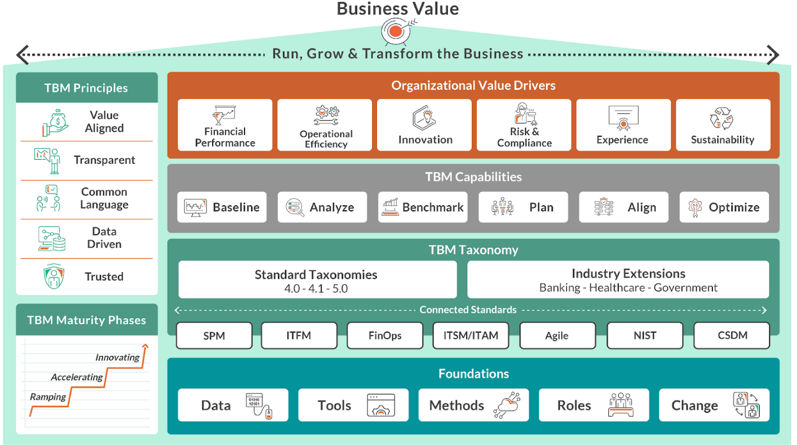

IS JOB index

<https://isjobindex.com/fullreport/>

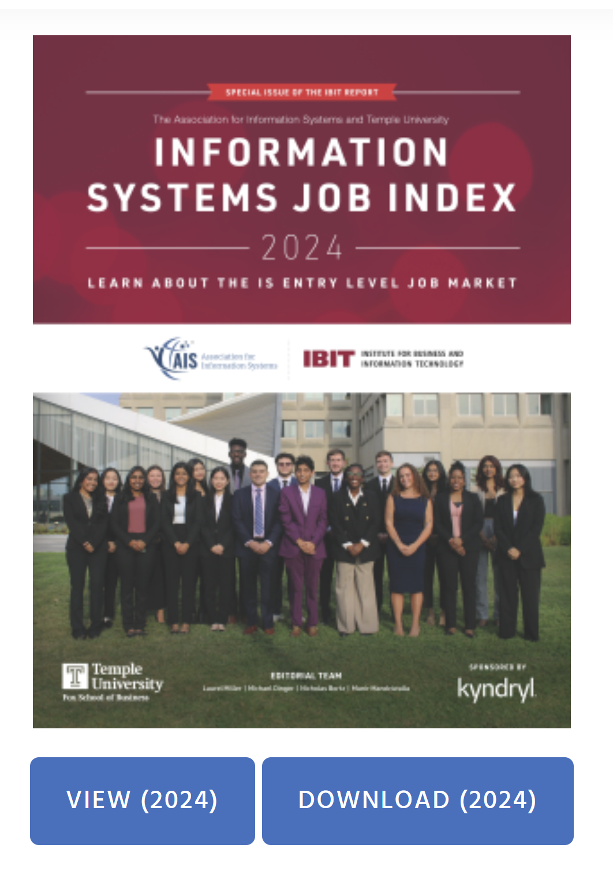

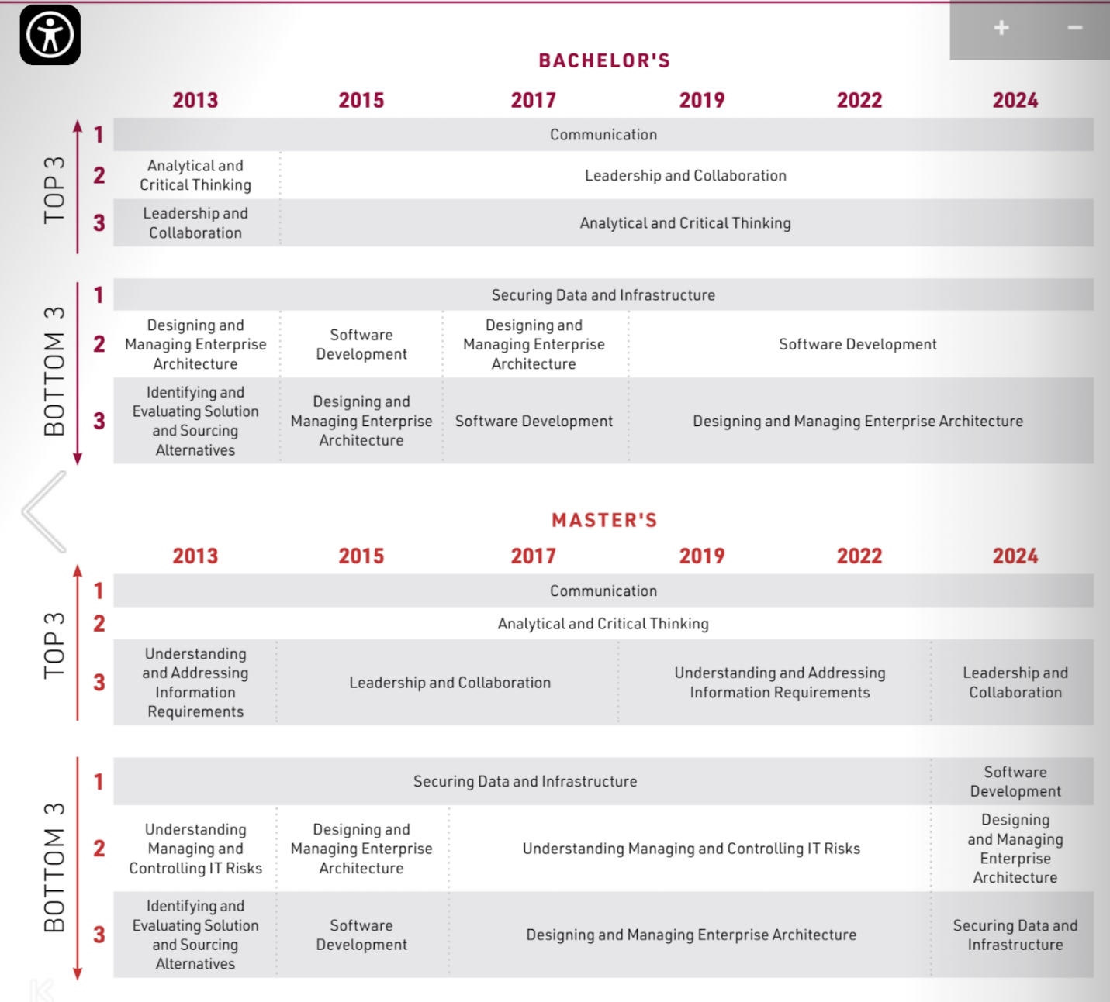

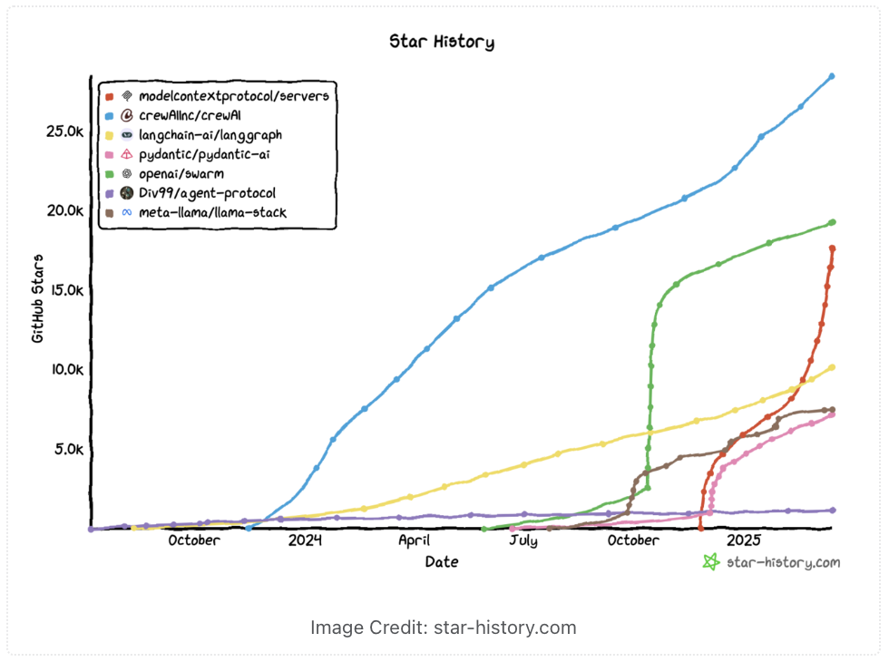

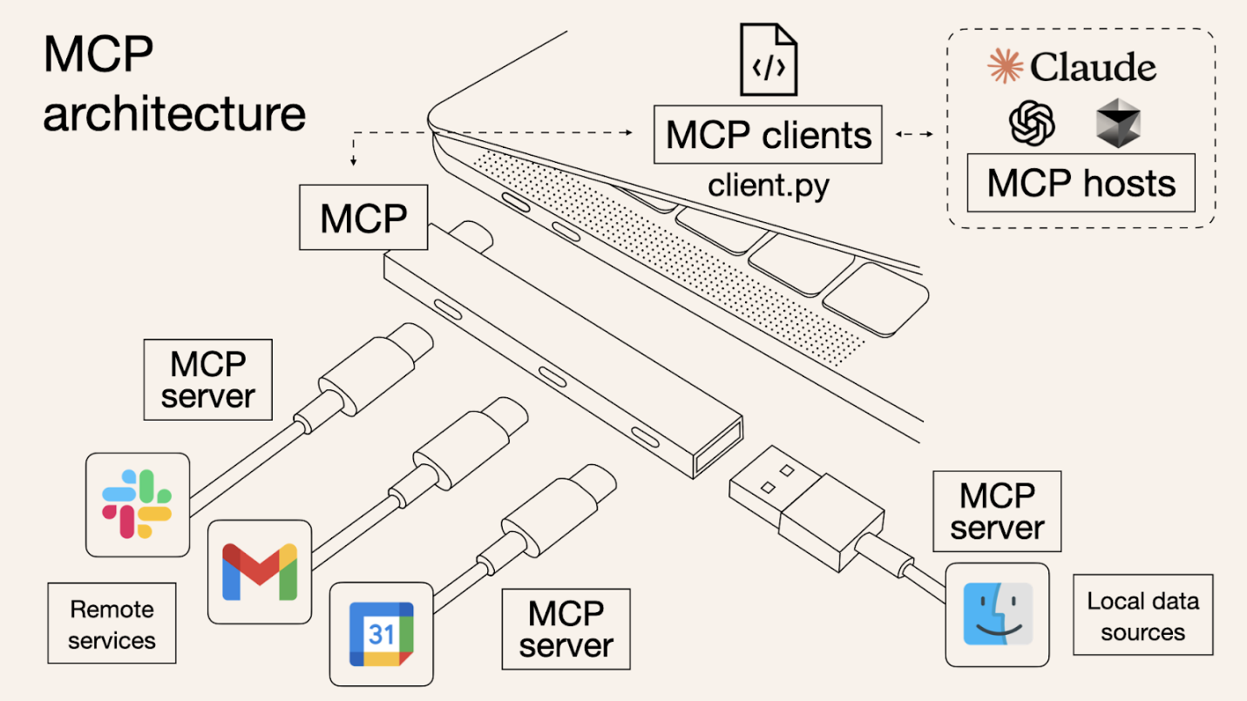

[**https://norahsakal.com/blog/mcp-vs-api-model-context-protocol-explained/**](https://norahsakal.com/blog/mcp-vs-api-model-context-protocol-explained/)

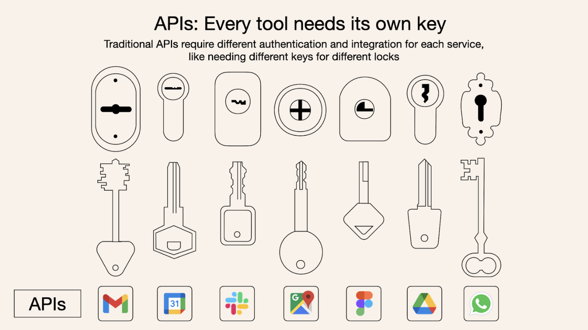

**MCP vs. API: Quick comparison[​](https://norahsakal.com/blog/mcp-vs-api-model-context-protocol-explained/" \l "mcp-vs-api-quick-comparison)**

|  |  |  |
| --- | --- | --- |
| **Feature** | **MCP** | **Traditional API** |
| **Integration Effort** | **Single, standardized integration** | **Separate integration per API** |
| **Real-Time Communication** | **✅ Yes** | **❌ No** |
| **Dynamic Discovery** | **✅ Yes** | **❌ No** |
| **Scalability** | **Easy (plug-and-play)** | **Requires additional integrations** |
| **Security & Control** | **Consistent across tools** | **Varies by API** |

**Certifications in innovation**

<https://www.giminstitute.org/>

<https://norahsakal.com/blog/mcp-vs-api-model-context-protocol-explained/>

**Week 12. Marketing and Halyk market case**

Example of Tech product lifecycle - LennyBot <https://www.lennybot.com/>

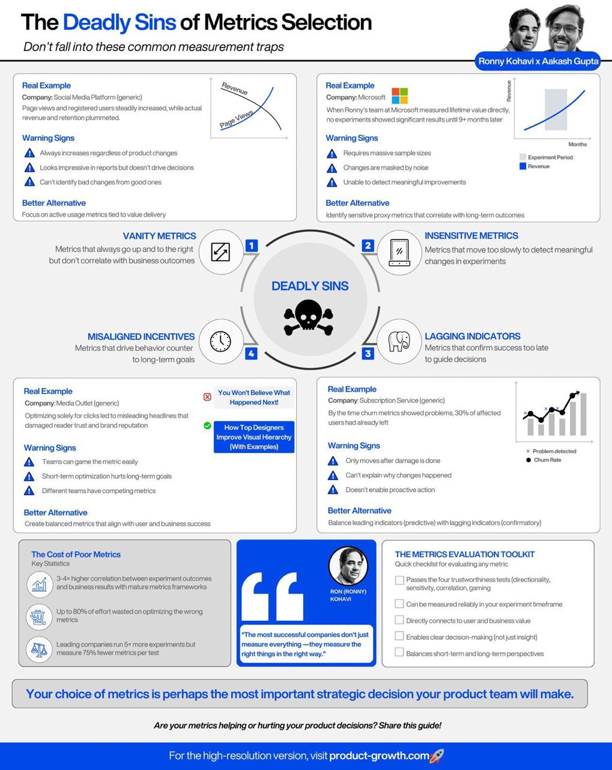

<https://ahrefs.com/>

**Halyk Market: Banking on E-Commerce in a Crowded Field**

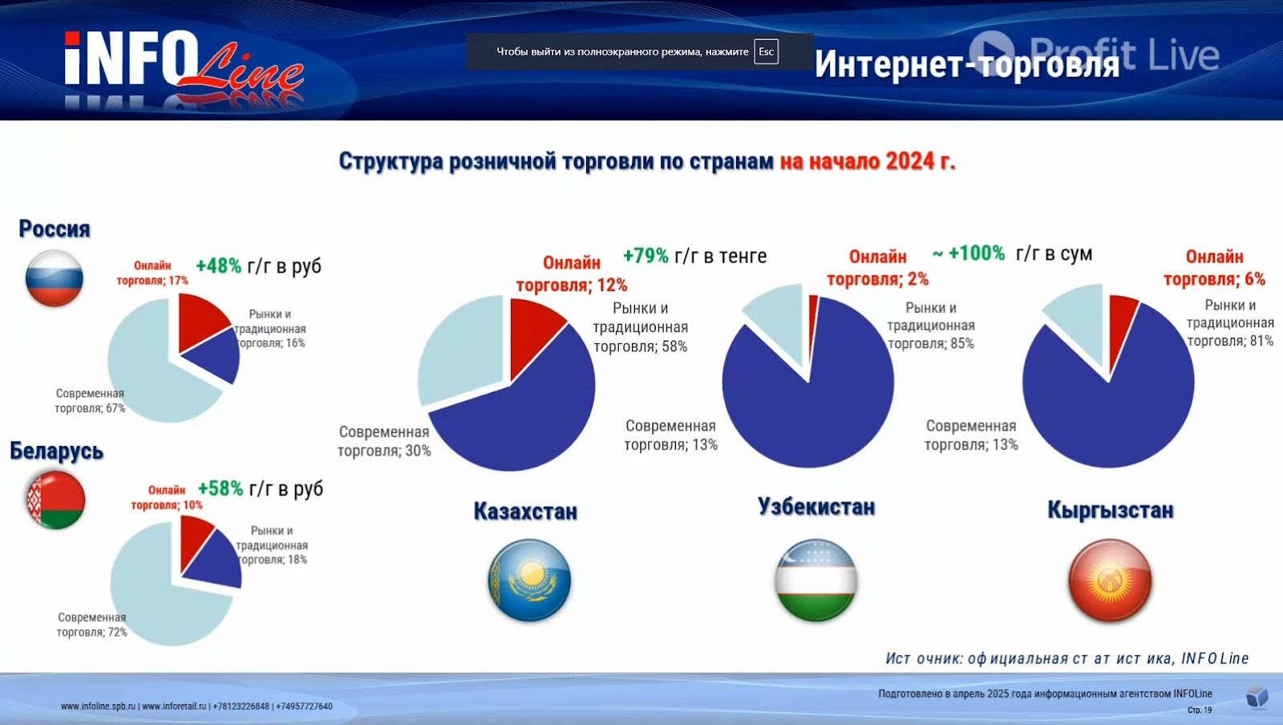

**Teaching Objectives:**

* Analyze the strategic challenges and opportunities for a traditional incumbent (a bank) entering a dynamic digital market (e-commerce).
* Apply strategic marketing concepts: Market Positioning, Customer Acquisition Cost (CAC), Return on Investment (ROI).
* Understand the operational challenges in digital product management, specifically the concept of a Software Backlog.
* Evaluate competitive dynamics in a regional e-commerce market.
* Develop data-informed strategic recommendations for a digital venture.

**Case Synopsis:**

Halyk Bank, Kazakhstan's largest traditional financial institution, headquartered in Almaty, has ventured into the fiercely competitive e-commerce space with its platform, Halyk Market. Launched amidst the rapid growth of online retail, Halyk Market faces formidable rivals: the dominant domestic player Kaspi Marketplace (part of the Kaspi.kz super-app ecosystem) and aggressive Russian giants Wildberries and Ozon expanding into Kazakhstan. With new leadership under Moldir (former CEO of Ozon Kazakhstan), Halyk Market is at a strategic crossroads. Can it leverage its banking parentage, carve out a distinct market position, acquire customers efficiently, manage its technology development effectively, and achieve a positive return on investment? Or will it become another casualty in the e-commerce wars? The potential expansion into neighboring Uzbekistan adds another layer of complexity.

**Background:**

* **Halyk Bank:** Founded over 80 years ago, Halyk Bank is a cornerstone of Kazakhstan's financial system, boasting millions of customers, extensive branch networks, and significant brand trust in traditional banking services. Its move into e-commerce aimed to diversify revenue, deepen customer relationships, leverage its existing customer base, and capture valuable transaction data.
* **Kazakhstan E-commerce Market (Early 2025):** A rapidly growing market, spurred by increasing internet penetration and mobile usage. Estimated market size: ~$4.5 Billion USD (GMV) in 2024, projected growth of 20-25% annually. However, it's highly concentrated.
* **Halyk Market Launch:** Initially launched ~2021-2022, leveraging the Halyk Homebank app. The strategy involved offering instalment plans (leveraging Halyk's lending capabilities) and cross-selling to existing bank clients.

**The Competitive Arena:**

1. **Kaspi Marketplace (Part of Kaspi.kz):** The undisputed leader (~60-70% market share estimate). Strengths: Seamless integration within the Kaspi super-app (payments, banking, classifieds, travel, groceries, marketplace), vast user base, sophisticated logistics (Kaspi Postomats), strong brand loyalty, aggressive marketing. Weakness: Potentially higher seller commissions.
2. **Wildberries:** Russian giant (~10-15% market share estimate). Strengths: Enormous product selection (SKUs), established cross-border logistics, competitive pricing (often), aggressive expansion strategy. Weaknesses: User experience sometimes criticized, reliance on cross-border fulfillment can impact delivery times.
3. **Ozon:** Another major Russian player (~5-10% market share estimate). Strengths: Strong technology platform, focus on user experience, developing local logistics infrastructure (fulfillment centers), significant investment capacity. Weakness: Later entrant than Wildberries, still building brand recognition in KZ compared to Kaspi.
4. **Halyk Market:** (~3-5% market share estimate). Strengths: Potential access to Halyk Bank's large customer base, integration with Halyk banking products (loans, bonuses), trusted brand name (in banking). Weaknesses: Limited product selection compared to rivals, developing logistics, potential channel conflict (seen as "just the bank's shop"), technology platform maturity.

**Halyk Market's Current Situation (Q1 2025):**

* **New Leadership:** Moldir's appointment brings valuable e-commerce expertise, particularly from a direct competitor (Ozon). Expectations are high for her to define a clearer strategy and accelerate growth. *Anecdote: Internal sources suggest Moldir's first priority was a "brutal assessment" of the platform's technical debt and user experience.*
* **Platform & Technology:** The platform integrates with Halyk's Homebank app but also exists standalone. User reviews (App Store/Play Store - See Exhibit B) are mixed: praise for instalment plans often contrasts with complaints about app speed, search functionality, and occasional bugs.
* **Software Backlog:** The tech team faces a significant backlog. Key items include:
* Improving search relevance algorithm (High Priority)
* Optimizing app performance/speed (High Priority)
* Developing seller analytics dashboard (Medium Priority)
* Integrating AI-driven product recommendations (Medium Priority)
* Expanding payment options beyond Halyk (Low Priority?)
* Bug fixes & UI improvements (Ongoing - High Impact on UX)
* Features for potential Uzbekistan launch (Strategic Decision Dependent)
* **Marketing & Customer Acquisition:** Primarily relies on cross-promotion within the Halyk Bank app/website and SMS campaigns to bank clients. Some digital advertising is used, but budget appears limited compared to competitors.
* **Customer Acquisition Cost (CAC):** Estimated average CAC is **$18 USD** per new purchasing customer. Acquisition via bank channels is cheaper (~$10), while external digital ads are more expensive (~$30). *Is this sustainable? How does it compare to an estimated Lifetime Value (LTV)?* (See Exhibit C)
* **Performance Metrics:**
* Active Users: ~500,000 monthly active users (MAU)
* Gross Merchandise Volume (GMV): Estimated ~$150 Million USD (Annualized for 2024)
* Average Order Value (AOV): ~$45 USD
* Conversion Rate (Visitor to Purchase): ~1.5%
* **Return on Investment (ROI):** The venture is currently **not profitable**. Estimated cumulative investment: ~$30 Million USD. Current operational costs exceed net revenue (commissions minus marketing/ops/tech). The board expects a clear path to profitability within 3 years. (See Exhibit D)
* **Positioning:** How is Halyk Market perceived? Is it a convenient add-on for Halyk Bank customers? A serious e-commerce player? A niche provider of goods on credit? Its positioning appears muddled compared to the clear identities of competitors. (See Exhibit A)

**The Strategic Dilemma:**

Moldir needs to present a clear strategic direction to the Halyk Bank board. Key questions loom:

1. **Focus or Expand?** Double down on the Kazakh market to gain share against giants, or divert resources to enter the less saturated but potentially riskier Uzbek market?
2. **Define the Value Proposition:** How can Halyk Market differentiate itself? Leverage bank integration more deeply? Focus on specific categories? Compete on service? Price?
3. **Optimize Spending:** How to reduce CAC while scaling user growth? Where should marketing investments be focused?
4. **Prioritize Technology:** How should the software backlog be managed to deliver the most strategic impact quickly? Fix the basics or build differentiating features?
5. **Path to Profitability:** What combination of GMV growth, commission adjustments, cost optimization, and improved ROI is needed to satisfy the board?

**Exhibits:**

**(Exhibit A) Hypothetical Market Positioning Map (Kazakhstan E-Commerce, Q1 2025)**

      High Selection Breadth  
          ^  
          |       Wildberries  
          |       Ozon  
          |  
Kaspi ---------+---------> High Integration / Convenience  
          |  
          |    Halyk Market (?)  
          |  
      Low Selection Breadth

*(Note: Placement of Halyk Market is debatable and a key point for student analysis)*

**(Exhibit B) Synthesized User Review Data (App Store/Play Store - Last 6 Months)**

|  |  |  |  |
| --- | --- | --- | --- |
| **Platform** | **Average Rating** | **Key Praises** | **Key Complaints** |
| Kaspi.kz | 4.8 | Convenience, Speed, Integration | Seller issues sometimes, Prices |
| Wildberries | 4.2 | Huge Selection, Low Prices | Delivery times vary, UI cluttered |
| Ozon | 4.5 | Good UX, Growing Selection, Pts | Less known than WB, Delivery |
| **Halyk Market** | **3.9** | **Instalment Plans, Bonuses** | **App slow, Search poor, Bugs** |
|  |  | **Trusted brand (bank)** | **Limited selection, Delivery** |

**(Exhibit C) Hypothetical Customer Acquisition Cost (CAC) Analysis**

|  |  |  |  |  |
| --- | --- | --- | --- | --- |
| **Channel** | **Spend (Last Qtr)** | **New Customers** | **CAC** | **Notes** |
| Halyk Bank Cross-Promo | $100,000 | 10,000 | $10 | Leverages existing user base |
| Digital Ads (Google/Meta) | $150,000 | 5,000 | $30 | Reaching outside bank ecosystem |
| Influencer Marketing | $50,000 | 1,500 | $33 | Experimenting, variable results |
| **Overall Weighted Avg** | **$300,000** | **16,500** | **~$18** | High reliance on cheaper bank channel |

**(Exhibit D) Simplified ROI Projection Scenarios**

|  |  |  |  |  |  |
| --- | --- | --- | --- | --- | --- |
| **Scenario** | **GMV Growth (Yr 1)** | **CAC Target** | **Net Margin Target** | **Projected Yr 1 ROI** | **Notes** |
| **Baseline (Current)** | **+40%** | **$18** | **-5%** | **Negative** | High marketing, moderate growth |
| **Aggressive Growth** | +100% | $25 | -8% | Highly Negative | High spend, focus on top-line |
| **Profitability Focus** | +30% | $15 | +1% | Slightly Negative | Cost control, optimize channels |
| **Balanced Strategy** | +60% | $16 | -2% | Negative | Blend of growth & optimization |

**(Exhibit E) Competitor Feature/Service Snapshot**

|  |  |  |  |  |
| --- | --- | --- | --- | --- |
| **Feature/Service** | **Kaspi Marketplace** | **Wildberries** | **Ozon** | **Halyk Market** |
| Super-App Integration | Yes (Core) | No | No | Partial (HB) |
| Loyalty Program | Kaspi Bonus | Discounts | Ozon Pts | Halyk Bonus |
| Instalment Purchase | Yes (Kaspi Red) | Partial | Yes | Yes (Core) |
| Own Logistics Network | Yes (Extensive) | Yes | Developing | Limited |
| Product Assortment | Large | Massive | Very Large | Moderate |
| Cross-Border Access | Limited | Yes (Core) | Yes | Limited |
| Seller Base | Large (Local) | Huge (RU+) | Large (RU+) | Growing (Local) |

**Assignment Questions for Students:**

1. **Positioning:** Based on the case and Exhibit A/E, analyze Halyk Market's current market positioning. Is it clear? Is it sustainable against the competition? Recommend a specific, differentiated positioning strategy for Halyk Market.
2. **Customer Acquisition Cost (CAC):** Evaluate Halyk Market's current CAC (Exhibit C). Is $18 acceptable given the market and potential LTV (Lifetime Value - *students may need to estimate or discuss factors influencing LTV*)? Propose 2-3 concrete strategies Moldir could implement to lower the blended CAC while still growing the user base.
3. **Return on Investment (ROI):** Analyze the financial situation based on the ROI discussion and Exhibit D. Which scenario seems most realistic or desirable for Halyk Bank? What key actions must Halyk Market take to achieve a positive ROI in the next 3 years?
4. **Software Backlog:** Review the items listed in the Software Backlog. If Moldir wants to implement the positioning strategy you recommended in Q1, how should she prioritize these backlog items for the next 6 months? Justify your prioritization based on strategic impact vs. estimated effort (students can make assumptions on effort).
5. **Strategic Recommendation:** Should Halyk Market prioritize deepening its hold in Kazakhstan or expanding to Uzbekistan in the next 18 months? Justify your choice, considering the competitive landscape, internal capabilities (including tech backlog), and financial constraints (CAC/ROI).

**Suggested 90-Minute Class Plan:**

* **(0-10 min) Introduction & Context Setting:**
* Brief overview of digital disruption in traditional industries (banking -> e-commerce).
* Introduce Kazakhstan's e-commerce landscape.
* Present Halyk Bank & Halyk Market as the case subject.
* Outline session objectives and introduce key concepts: Positioning, CAC, ROI, Backlog.
* **(10-25 min) Case Presentation:**
* Walk through the case details: History, Competition (show Exhibit E), Current Situation, Leadership change, Strategic Dilemma.
* Present key data points and Exhibits (A, B, C, D). Ensure students understand the metrics.
* **(25-55 min) Small Group Breakout Session:**
* Divide students into groups of 4-5.
* Assign specific questions (e.g., Group 1: Q1&2, Group 2: Q3&4, Group 3: Q5 & overall strategy) or have all groups tackle all questions.
* Task: Analyze the case using the provided data and concepts. Prepare brief answers/recommendations for their assigned questions. Encourage debate within groups.
* **(55-85 min) Group Feedback & Class Discussion:**
* Bring groups back. Ask representatives to share their analysis and recommendations for each question.
* **Facilitate discussion:**
* Compare positioning strategies. How viable are they?
* Debate CAC optimization ideas. What are the trade-offs?
* Discuss the path to ROI. Is the bank patient enough?
* Challenge backlog prioritization choices. Why one feature over another?
* Debate the Kazakhstan vs. Uzbekistan expansion decision.
* Professor guides discussion, ensuring concepts are correctly applied and linking insights back to digital innovation principles.
* **(85-90 min) Wrap-up & Key Takeaways:**
* Summarize the core challenges Halyk Market faces.
* Reiterate the importance of strategic marketing (Positioning, CAC) and operational management (Backlog, ROI) in digital ventures.
* Highlight the complexities of competing against established digital-native players.
* Briefly mention potential real-world parallels or outcomes (if known/applicable).

*Disclaimer: All numerical data, market shares, CAC, ROI figures, and specific backlog items are hypothetical estimates created for educational purposes within this case study. They aim to reflect plausible scenarios but are not based on actual internal Halyk Market data.*